Jan Matejko Academy of Fine Arts
Department of Sculpture
2018/2019

Monika Rościszewska
THE PROCESS OF COGNITION IN THE CREATIVE ACT
Doctoral dissertation

Supervisor:
prof. Józef Murzyn

Reviewers:
prof. Małgorzata Dajewska
dr hab. Stanisław Brach, prof.ASP

Acknowledgements
I would like to thank the Department of Glass and Ceramics in Wrocław, in particular:
Professor Małgorzata Dajewska,
Professor Kazimierz Pawlak,
Professor Krzysztof Rozpondek,
Agnieszka Leśniak-Banasik PhD,
Dagmara Bielecka PhD
Marzena Krzemińska-Baluch PhD
Beata Damian-Speruda,
Magda Włodarczyk.

Table of contents
Introduction 7
Creativity 8
The source of cognition 9
The known influences the known 10
Awareness (perception) 11
Intentionality 13
Remembered image - inspiration 16
Body as the record of emotions 17
Intellect vs emotions - awareness 20
Body as a map 24
Embodied cognition 31
Organic thinking 32
The experience of body 34
Memory vs body 36
Conclusions 42
References 48

Introduction

This work is an attempt to present the factors that have affected my creative act and the concurrency and the interdependence with the internal communication that accompanied it.
In the dissertation I would like to present the conclusions concerning the process of cognition, self-cognition in a creative act and the factors that affect this process.
Does rational vision, including the mind and information it includes, form us when it comes to cognition in the creative act? Is a bodily recognition possible, in which these experiences, and the images connected with them, affect the process of cognition and recognition in the creative work?
I am trying to present the reasons affecting the man in the creative process. The reasons that are crucial factors that influence the process of cognition.
These factors and their influence become thee building materials of the knowledge; the dialogue of the internal communication becomes a part of the cognition – self-awareness.
My search is focused on existence, the relation of the cognition that takes place in the creative process.
Self-awareness is a creative road of development. In order can get to know your own way, it is significant to explore factors that influence the process of cognition and learning.
My deliberations are based on own experience, literature which inspired me while doing the research, at the same time giving them the direction of a creative work. I make an attempt to explore this creative process, presenting factors that are present in the process of cognition.

Creativity
As artists we are passive against the things we create. We make our images real and give them physical presence. We state questions and at the same time we need to answer them.
Forming them becomes an important direction in the cognition and self-awareness. The passiveness in watching builds an image and becomes the only possibility to be seen. The simultaneous suspension of views is the crucial factor that helps one understand the process.
In my former works I tried to show the effort and the struggle of the man in the world. I presented through them the antonym of human existence. Through connecting totally different materials whose difference of shape excluded cohesion, I attempted to the discrepancy of the final form. The one, in which the materials become each other’s complement in the final form.
Organic structure connected with geometric form were at the same time different and supplementary to each other.
The materials presented the clash of sensitivity, fragility with the eternal factures of iron frames of consumerism. Sensitivity and diversity in life demands a lot of attention and resistance from a man. It is a particularly big challenge when it comes to an artist.
I devoted most of my time to those struggles. This matter bothered me during my studies. The conclusions I drew brought ne to a place, in which it is impossible to define myself in my art. Creative sensitivity makes us be in a constant movement, on the next stage of development. It allows us to see what is mostly unnoticeable, what seems to be of little importance.
While creating subsequent works I thought about the factors that rule my creativity. They are not only filtered by the knowledge I gain, but they are the result of the experiences I remember and that are somehow written in me that constitute individual creating path.

The source of cognition
Feelings are filtered by experience. It has an influence on us, our subconscious. I understood that in order to understand individual direction, the understanding of factors that are written in us through previous experiences and having an influence in the creative process is needed.
In case of an artist, the explicit self-definition is impossible, since the earlier perception is being replaced with a new one. The experience of all periods and all images influences it. Including those written in the memory. They become apparent through the latest experiences.
My next artistic actions explored the process of cognition, the experience having an influence on a creative process – with a simultaneous change of observations and the already acquired experience.
This correlation of the experienced with the one being experienced suggested next questions about cognition, to know, and rather than that getting to know the present time and inducing collision with the experiences from the past.
The awareness allows for understanding of the direction of the individual road, path of personal experiences which in the future will influence the process of cognition.
It can also allow to stop in order to go further.
The presence holds the past in its hand. The sensitivity of the reception allows for defining it and transforming it along with experience, which is in the future in the artistic language.
I wonder, to what extent experience or remembered image affect the next experience in the creative act.
While experiencing the new, we activate the old and simultaneously build new things.

The known influences the known
Every time the memory reconstructs the remembered image in a new way. The way memory presents it allows for the restoration of the previous experiences.
My evaluation is preceded by the images remembered before. The direction of my search is mostly chosen by the subconscious that is influenced by the images from all times.
Experiencing the cognition influences the process of reception. While reading the image, one changes the relation with it along with getting the knowledge.
The awareness is the basic factor that allows for reading out the influence of the known on the one that is being known. It is a significant element of the creative process.
The knowledge itself is the only factor enabling the creative process, since spontaneity is the component of the creative process. If the theory of the knowledge came to the fore, the entire production would be subject to control.
The openness in the cognition enables to notice factors that have an influence in the creative process. The openness lets understand relations which emerge in the course of the creative process are emerging and are important for the process of cognition.

Awareness (perception)
The awareness is a bundle of intentions. Jean-Paul Sartre describes in The Imaginary the knowledge as the factor that constructs what is seen. The French philosopher says also about the fact that the notional image does not work, “it is not a complete sentence” , as long as it does not see the light of day, since then it is possible to be seen and read out. The author also adds that it can be the other way round: the internal language cannot be an image, since it can be read out only while being outside.
Awareness is depicting. It is the awareness of the object in the image, and not the awareness of the image that helps me see the image. As the recipient of the work I define it.
I direct knowledge at the object I am looking at. I define it, I also establish it through the past experience that has been defined. Experience also becomes the faith in what I can see.
Often, I provide the object I look at with emotions and faith. Subconscious images influence the image I’m watching.
Ingenuity is a matter of concern, since it goes beyond the comfort of predictability.
The things that in the perception take place one after another are simultaneous in the image. We see the image in one piece. One’s own intellectual and emotional experience reads it out with its own alphabet.
The understanding awareness can sometimes have a depicting structure. In this case, an object, an image seems to be a straight intentional correlate of the very act of understanding. The understanding becomes real in the image. The image does not teach anything.
Alfred Bineti and other psychologists came to a conclusion that “the image is obstructing the thought, but in turn the thought is responsible for the disturbed balance and not an image. The thought is not noticeable on the object, and appears to be the object.
Understanding is a move that does not end. It is a reaction of the mind to the image in the form of another image, and then of another image, and so on. In theory it leads all the way to infinity.
The experience that builds and expands the knowledge becomes a gate to the further recognition, and the awareness is opens the space of internal recognition.
Influence of the image during the process of reception (cognition) means understanding it through the reaction of the mind to the image in the form of another image, and then the next one ad infinitum.
But the reception of the mind itself would be incomplete when deprived of the possibilities empiricism is giving, therefore I would like to appeal to the phenomenological psychology of Sartre’s imagination. The philosopher distinguishes perception from an image and gives more possibilities to perception. Sartre does not see them as equally important, since if they were the elementary factors of similar quality, they would be mutually exclusive.
The faith is an act of constituting, and the existence of unreal objects is a direct correlate of this act of faith. I combine the current scenes with the past ones by means of empty intentions. Unreal existence of the object and real existence of the awareness are simultaneous.
There is no doubt that people who react with words, like “horrible, repulsive” have not been moved at all.
The memory gives to an unreal object quality which the current awareness could not give.
In my opinion we are not able to classify perceptions. We can list the factors affecting this process, but the unambiguous definition is not possible, since psychological relations are a sum of many elements that are not possible to determine explicitly.

Intentionality
Calling the process of cognition, the “cognition” already defines this phenomenon and places it in the framework of criteria of the definition it has to comply with.
Maurice Merleau-Ponty in the Phenomenology of the perception wrote that “one always assumes them already when one thinks that one discovers them”.
It is possible to explain it with an example, in which the object noticed by us in a given moment is perceived as something different by other people.
The nervous system influences the process of cognition, thanks to it a given object is being read out in a particular way. What I have in mind is a colour that, connected with memories that we keep, influences the way we receive it.
Intentionality in the process of cognition should not contain theories that would suggest the way of exploring. I believe that getting to know one’s intentionality is connected with self-awareness, and consequently, with the individual way of discovering, experiencing and defining.
Analytical cognition is not natural, there are gaps in it. Defining requires appropriate conditions, it is evaluated in the context. Evaluations, impressions are taking place by defining of the process, of theory.
In the process of cognition, in order to see, one should cease to expect. One should suspend all assumptions and hypotheses that define the thing that is the subject of cognition. In order to see and explore one needs to suspend their views.
The image is first seen in reality. Reality is the basis that allows for the existence of an image. It is a process of reception. Reality motivates the process of imagining. It creates the essential elements of reality, i.e. the reality-creating awareness without the depicting awareness.
Even in the idea in order can see some unreal object, we must move away from real world in which this object doesn't exist. Hanging views is necessary can for oneself depict it.
Even while imagining, in order to see an unreal object one has to depart from the real world, in which the object does not exist. The suspension of views is necessary to imagine this.
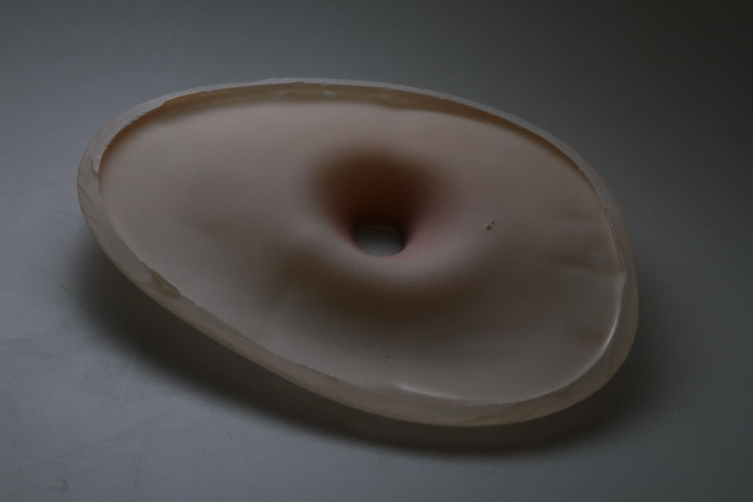
“The process of cognition” series, 2018., h 5x 30x 35cm, blasted glass
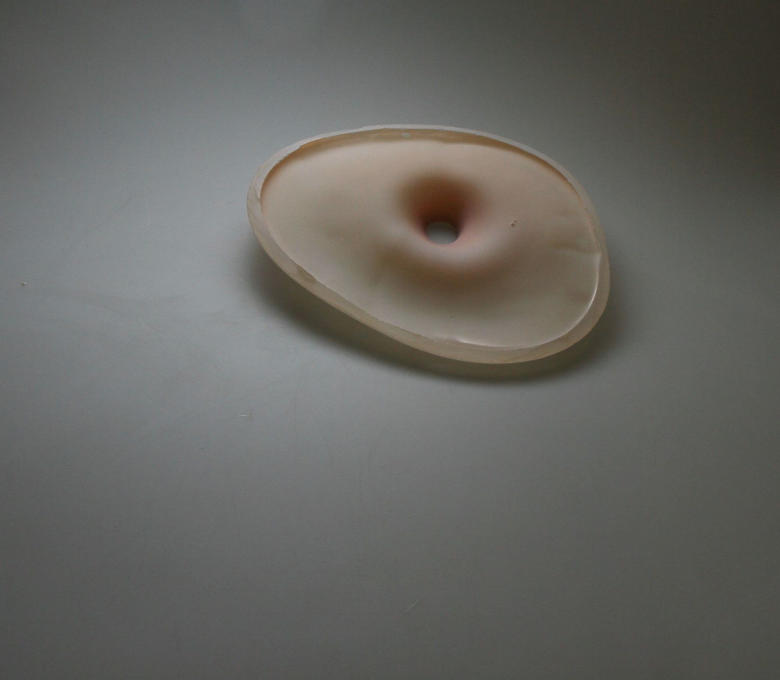

Remembered image – inspiration
The creative act is preceded by image, inspiration, awareness which grows in a creative mind as something unreal, and at the same time so real in terms of feelings that it is hard to say that the image did not exist.
In the course of building an unreal image in the mind the knowledge plays the role of perception. Even though it is unreal and still non-existent, it exists in the mind for the author. Let me quote Sartre at this point: “Certainly unreality always receives and never gives” . Unreality is a simple reflection of emotion". Emotions evoke the remembered images.
The feelings, so reach and unreal, were described by Sartre as poor, spasmodic, repulsive. He also wrote about the function of their existence, and the fact that so that they can exist, they need the non-existence; about the fact that the enemy to whom we talk, loses the power, because depicting the enemy is the only way to give them the sense of existence.

Body as the record of emotions
Cognition to know always refers to previous experiences that become the base. In this process a body plays the major part.
The brain is not the only source of cognition. In the process of reception, we use sight, touch, hearing. They are not separate elements, but act together, having a common language of the understanding called the embodied cognition.
I think that the remembered images have a significant influence on both the process of creation and reading it out. Determinants (psychological) are essential in the context of the emotional of the body.
Existence of the time is recorded in our bodies. They become the factor of the awareness of cognition. Merlau-Ponty defined the body as the centre, in which we recognize the essence and existence we find in perception.
The process of becoming individual - indivisible starts from the inside, and the outside factors are the determinant needed to achieve this state. However, it is worth noticing that the building of the internal part is closely connected with external factors that are part of a given stage of the development.
The internal insight is significant in order to understand relations and intentions of the artistic direction one chooses. It becomes the guide of one’s individual path.
.

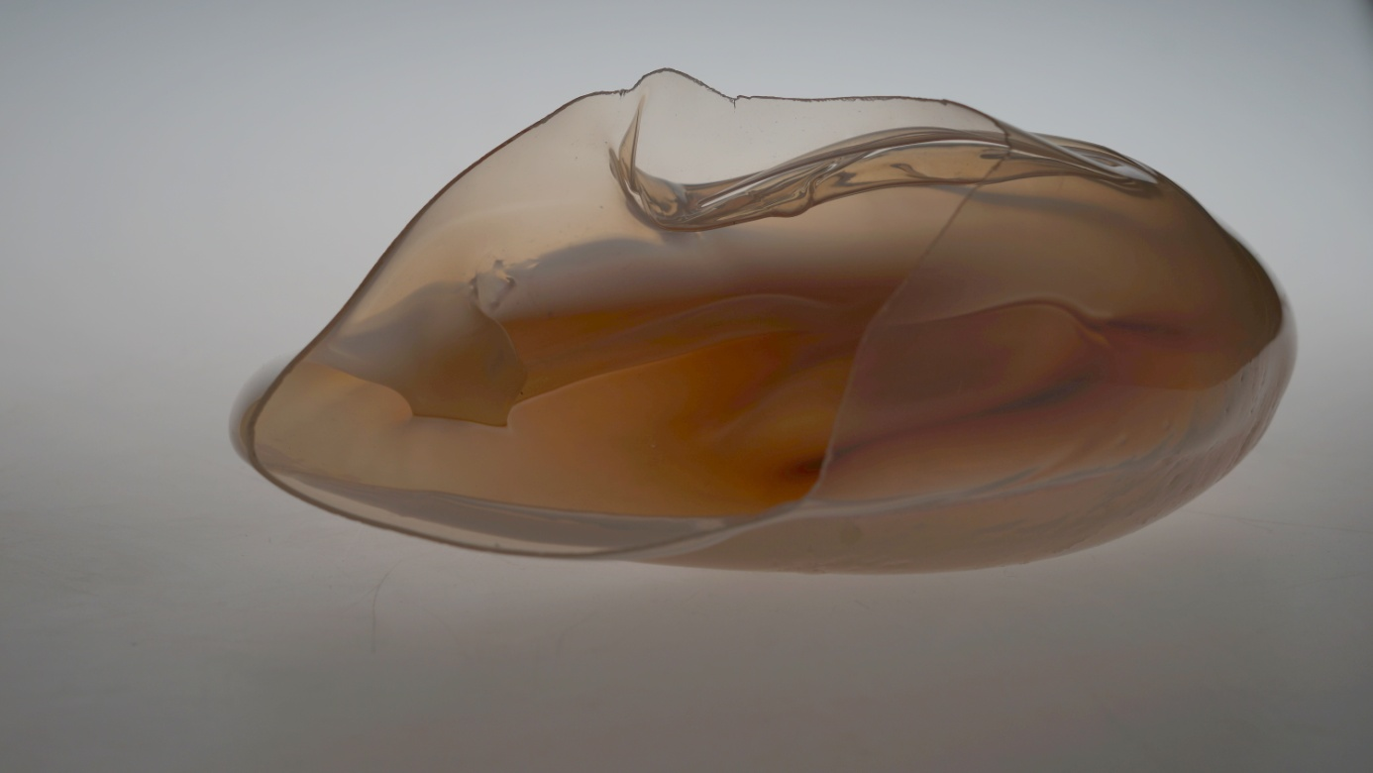

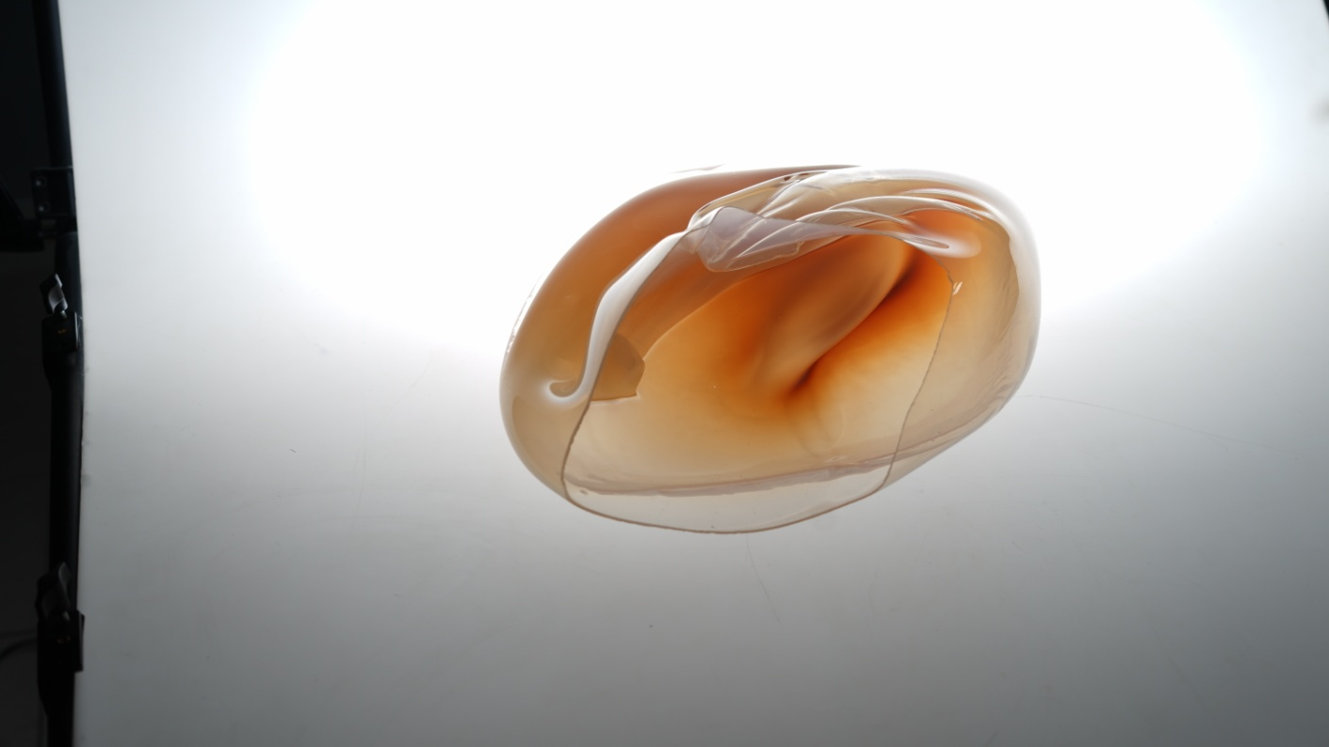

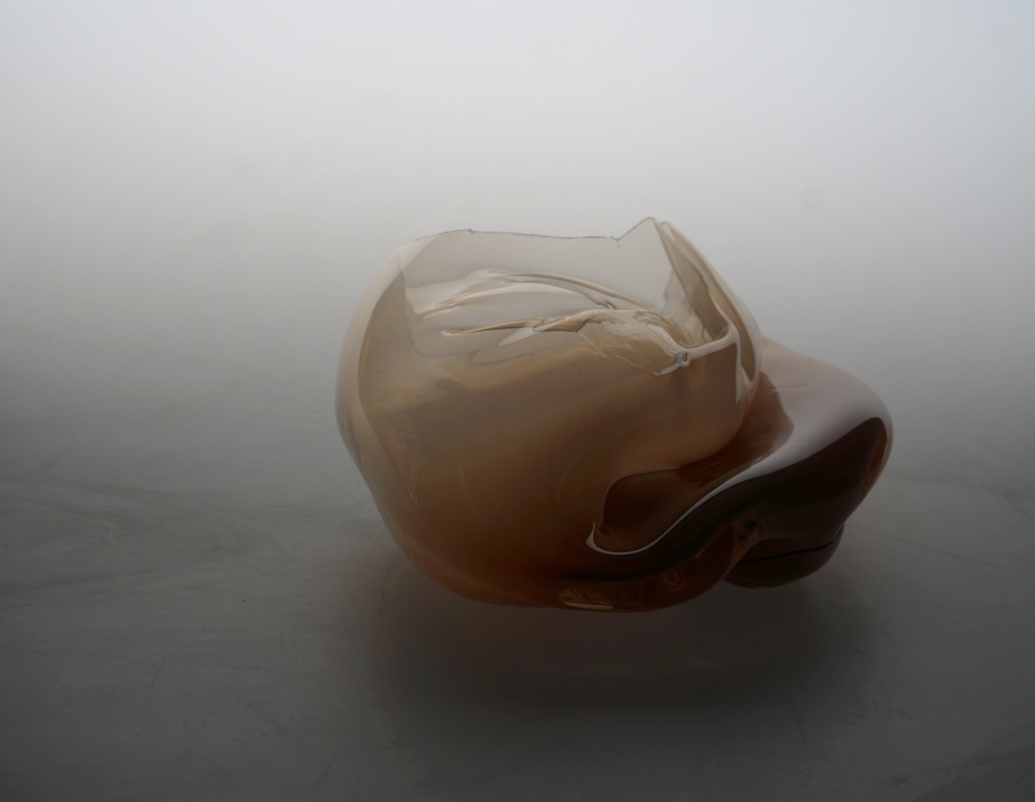

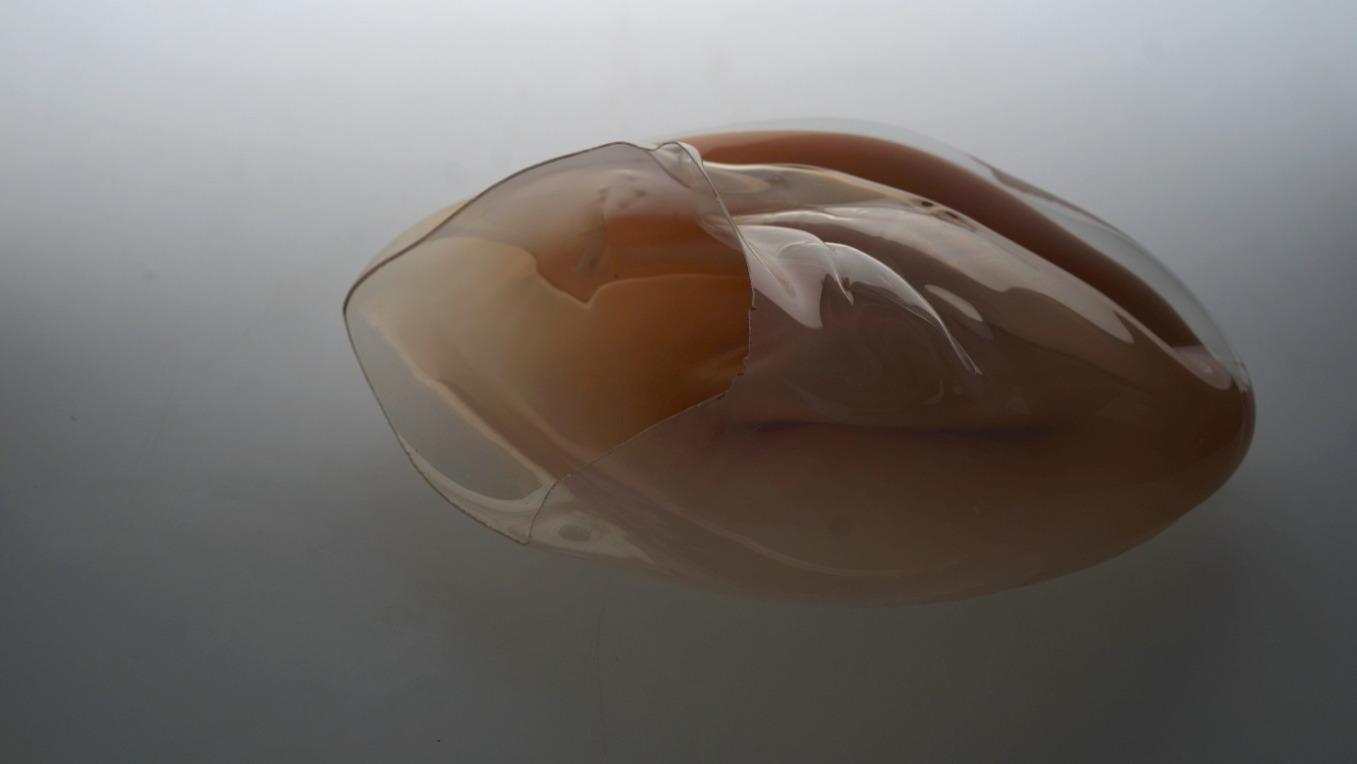
“The process of cognition” 2019 r., h 28 x20 x 45 cm, glass

Intellect vs emotions – awareness
Language extends our thought, makes it specific, teaches us its interiority. Yet the image does not determine our knowledge, since it is determined by the knowledge itself. We build an image in memory through experience.
Sartre writes that the freedom of awareness is not equal with freedom. It is not the negation of the world as such, but with a negation of the world from a certain point of view. It is established against something that is constituted in the world (just like the artist is constituted in the world and observes from a certain point of view the establishment of the absent image in the real world) .
Emotional building of the image is possible thanks to imagining.
“Imagination can undergo the development, when the awareness is free from all reality, and this freedom is subject to defining by being in the world".
Motivation show the nature of the unreal object.
In the process of creation, inspiration is an inseparable component of artistic work. Collected images, experience influence the process of creating an art of work.
A work shows the motivation of cognition, uncovering the path of internal cognition in the creative process. The awareness is revealed through a creative act. The author always expresses himself or herself from some point of view of the world he or she lives in. In spite of attempts to break free from real world in the creative process, the world itself defines freedom.
A free awareness is the motivation. The world is the reason why the work appears. It makes the works of art exist and is a soil for the awareness that emerges in the creative act.
Imagining is free. It comes into existence in unlimited awareness which, thanks to the he fact that it is free, can negate world by producing notional images. The present reality is the background of imagination. With reference to it is possible to build notional images which are the essence of creative process of an artist, “being in the world” is the necessary condition of imagination.

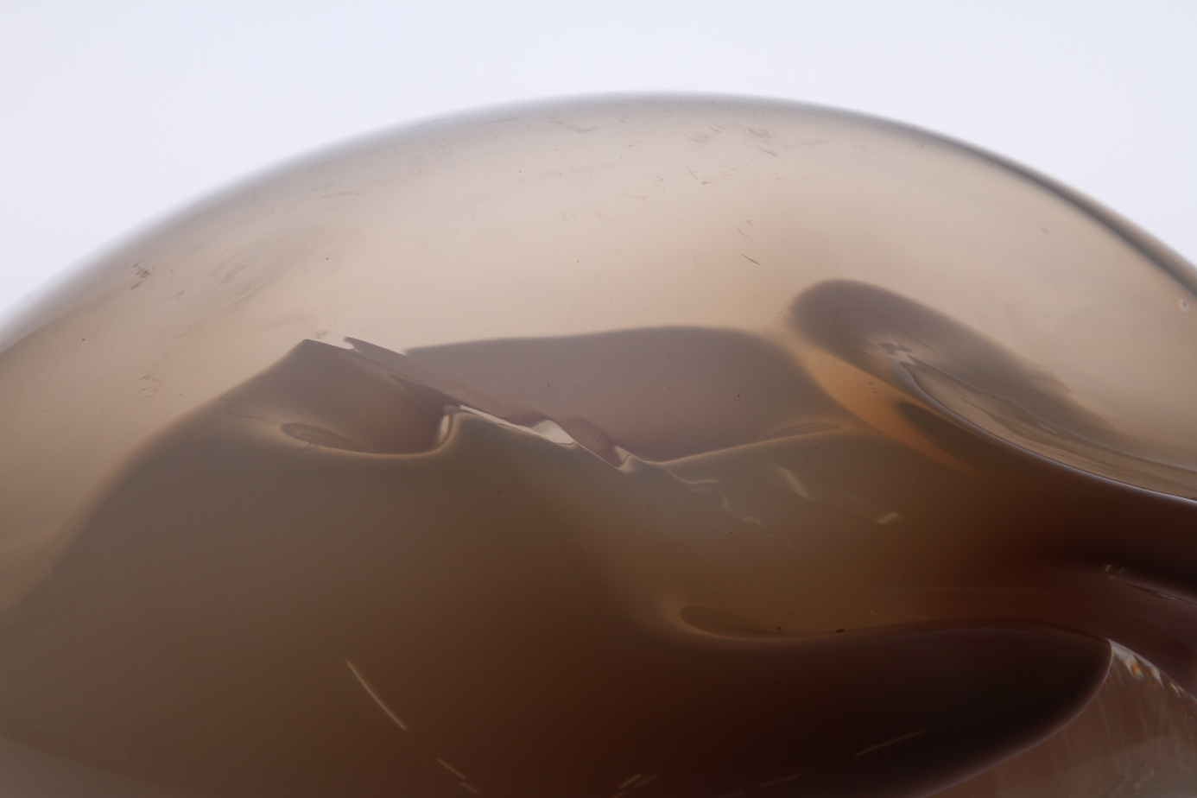
“The process of recognition” 2018, h 10 x 35x 31
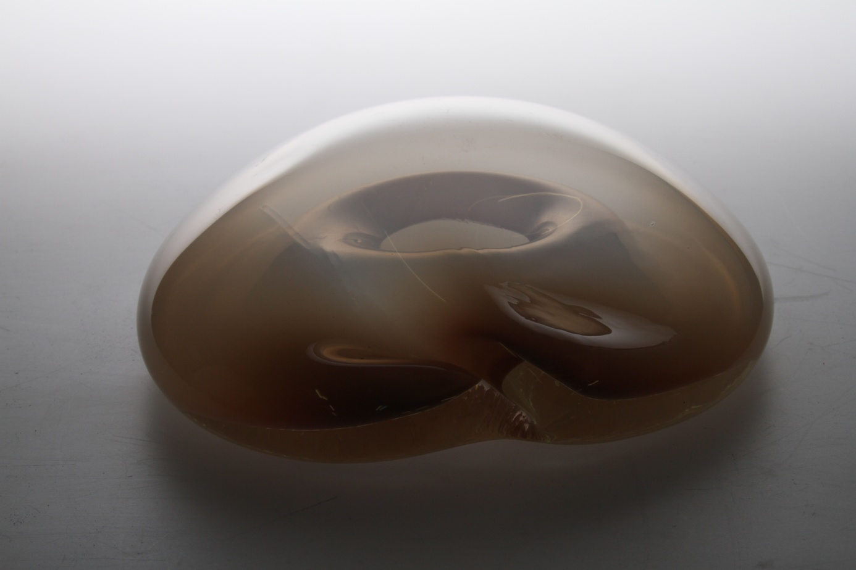

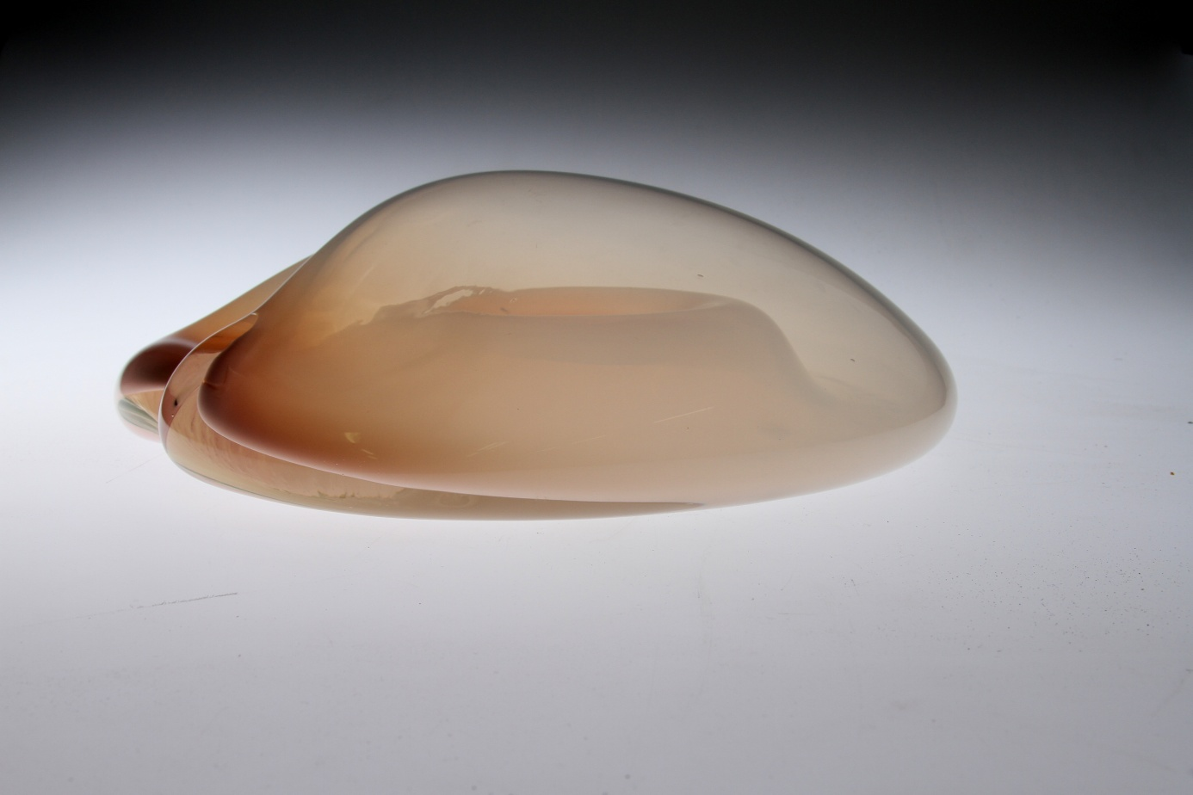

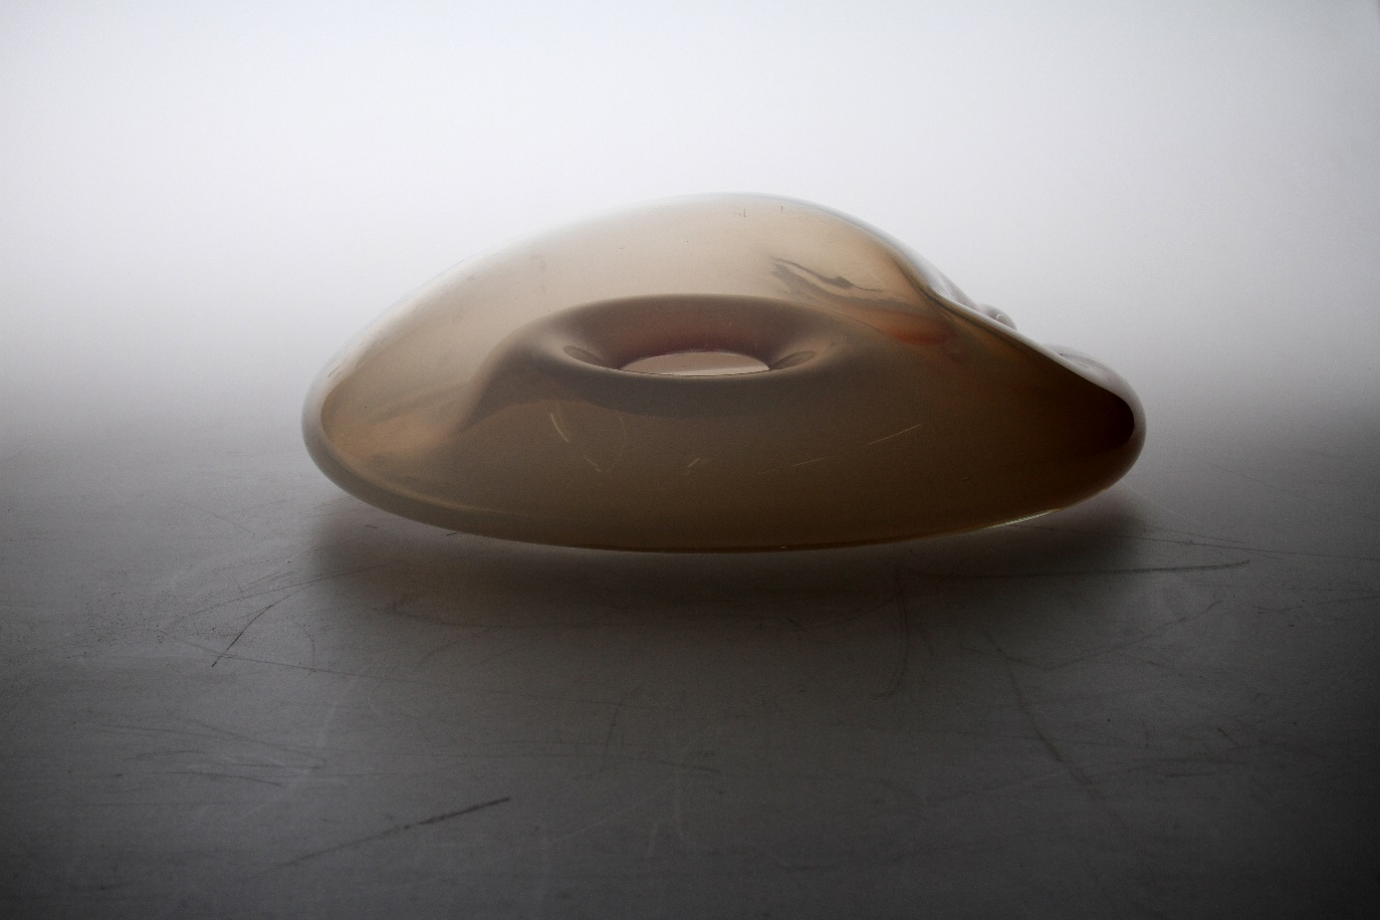
“The process of recognition” 2018, h 10 cm x 35 x 37 cm, glass
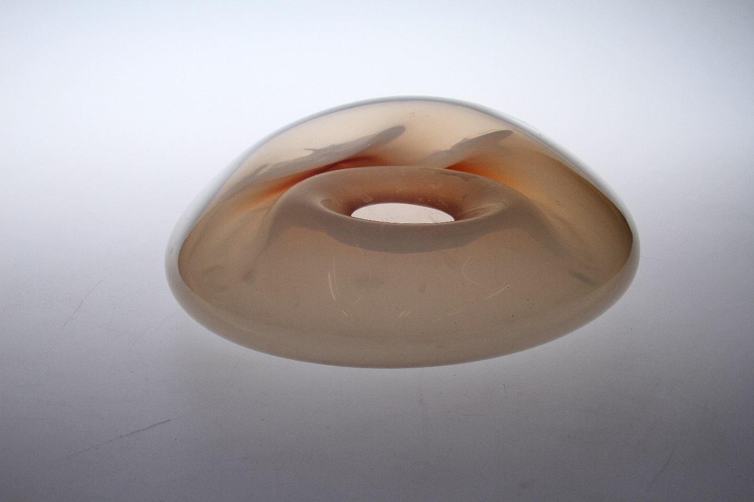

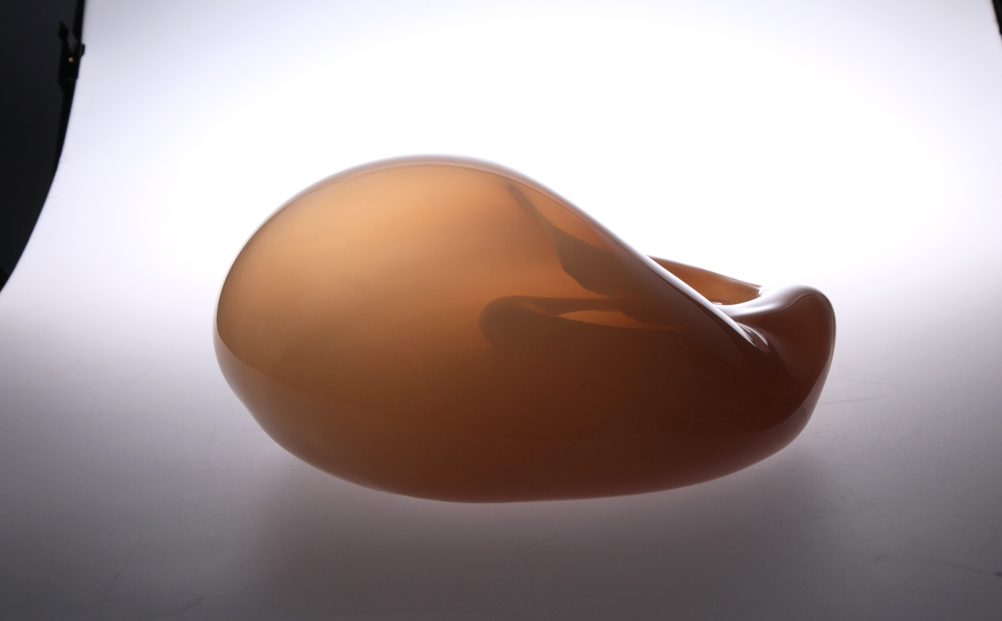
“The process of recognition” 2018, h19 x 38 x 45 cm

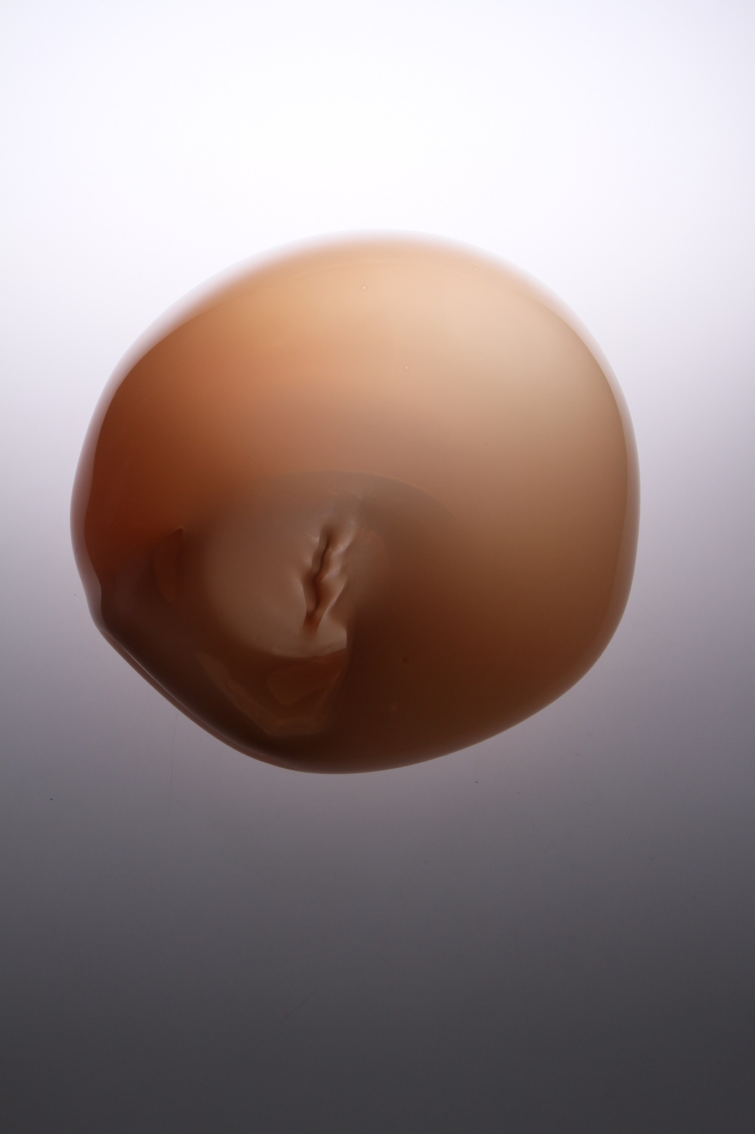

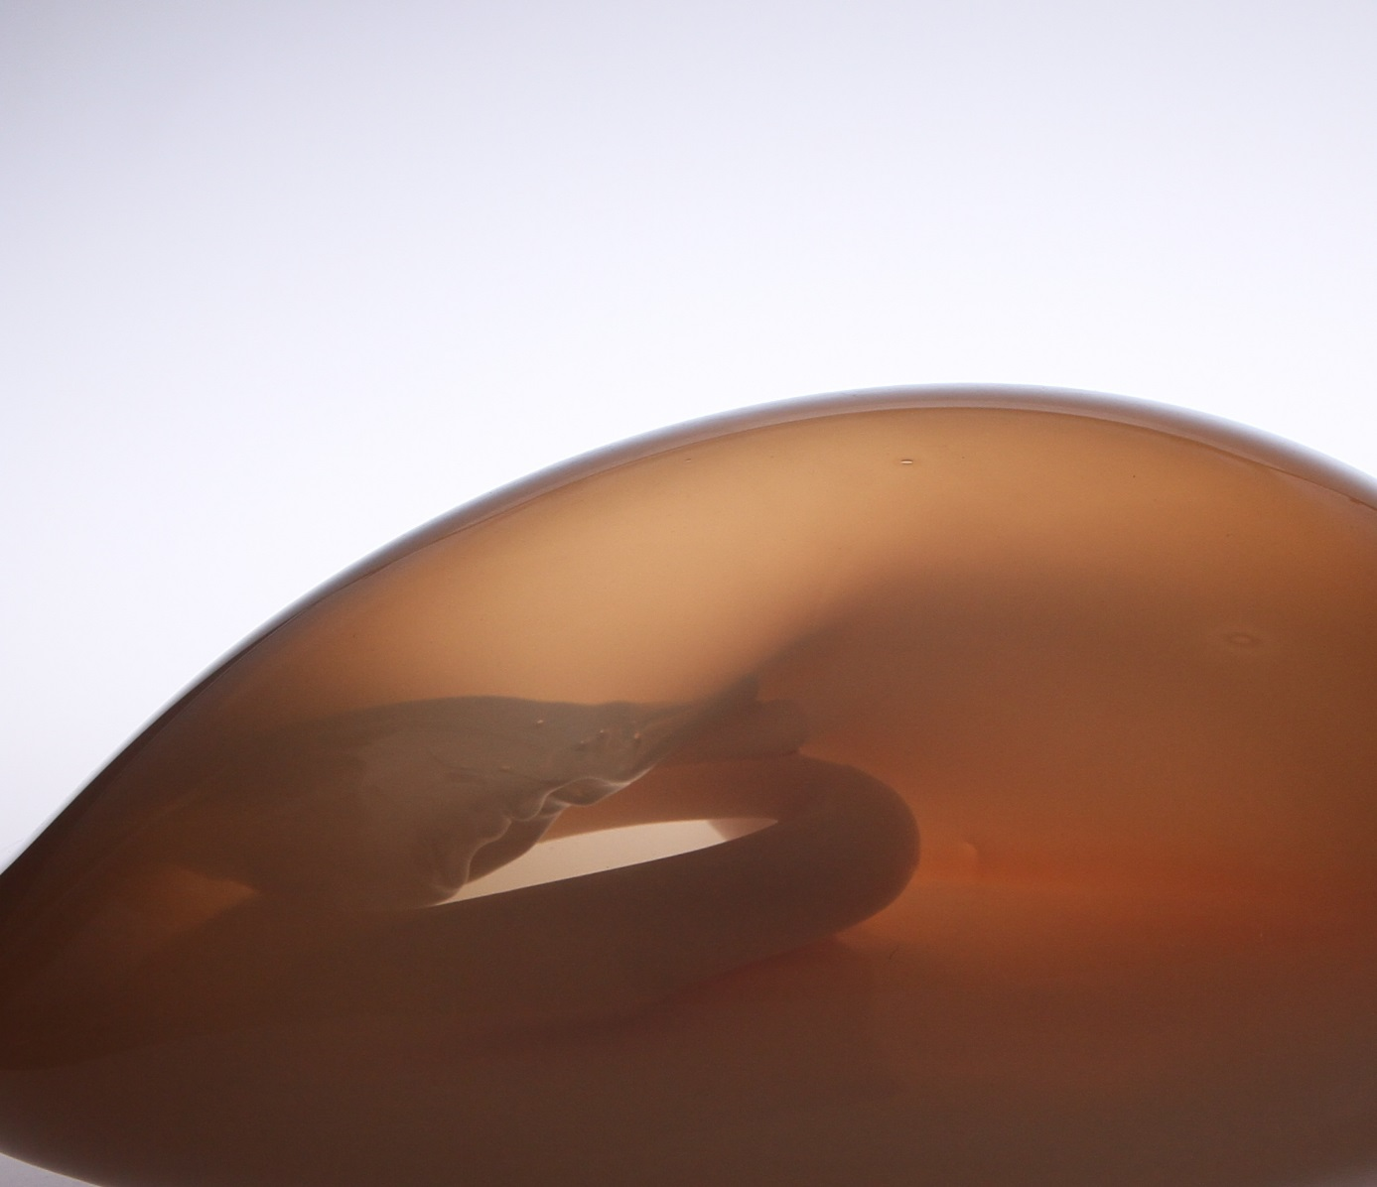
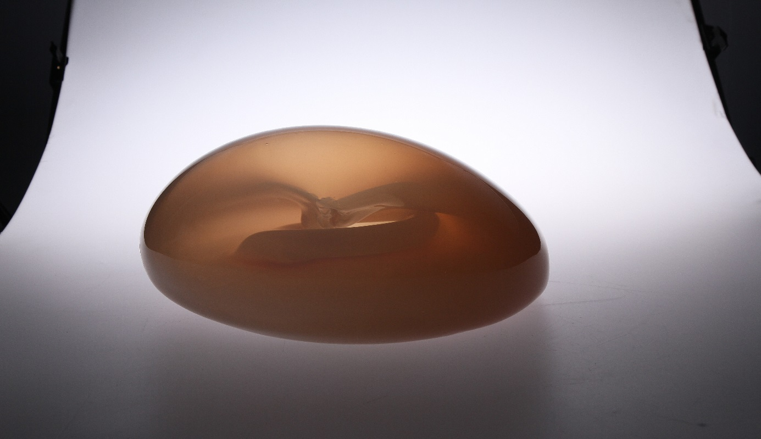
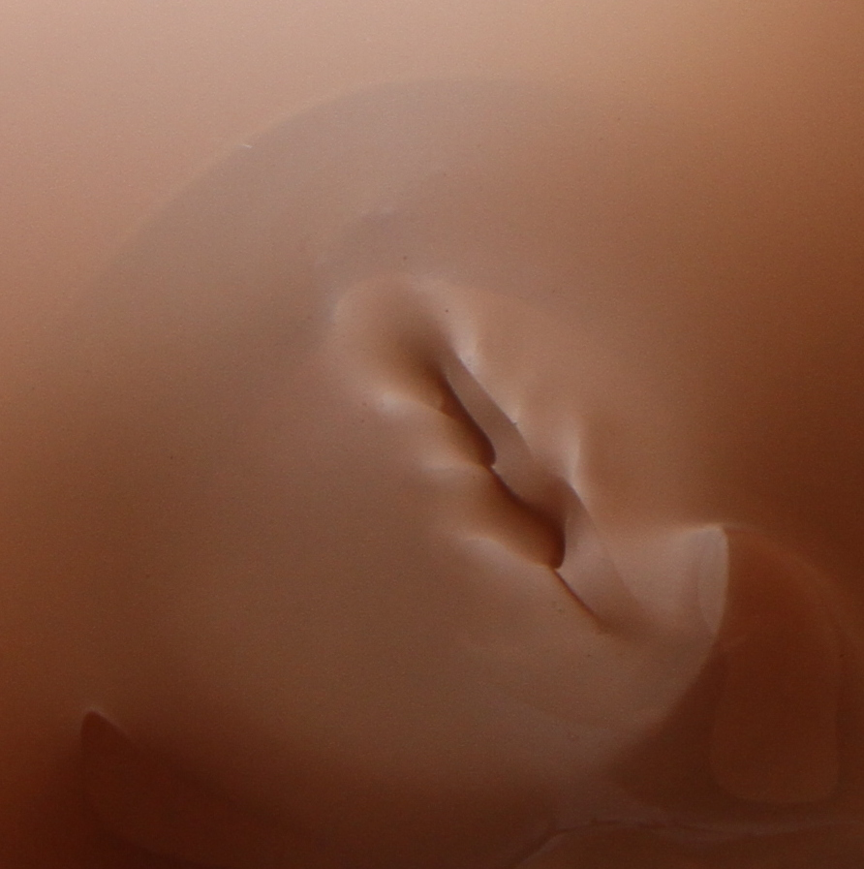

The body as a map
In Developmental and Psychodynamic Perspectives on body images David W. Krueger described the influence of experiences that affect both the inside and outside of the body. Carnality plays an important role in building the internal “I”.
The author divided the influences of experiences into three bases: psychological experiencing of corporal impressions, the perception of the function of the body and the body image.
An ability to be in touch with your own body and its needs is a natural process of feeling which is necessary in the process of cognition. It is an internal cardiac monitor that works simultaneously with the body. Even breath is a basic function that goes through the whole body.
Memories from the early period of life are written in the body. It does not omit any stage of our life. In the course of the reception of the presence, the past accompanies us. It is a parallel process.
Merleau-Ponty said about the current perception: “while we base something on the current position, we take into consideration a number of previous positions that are included in themselves”. He also said that “one cannot connect some of the movements with corporal mechanics, and other with awareness: body and awareness do not restrict each other, they can be only simultaneous. The whole body takes part in the construction of an image.

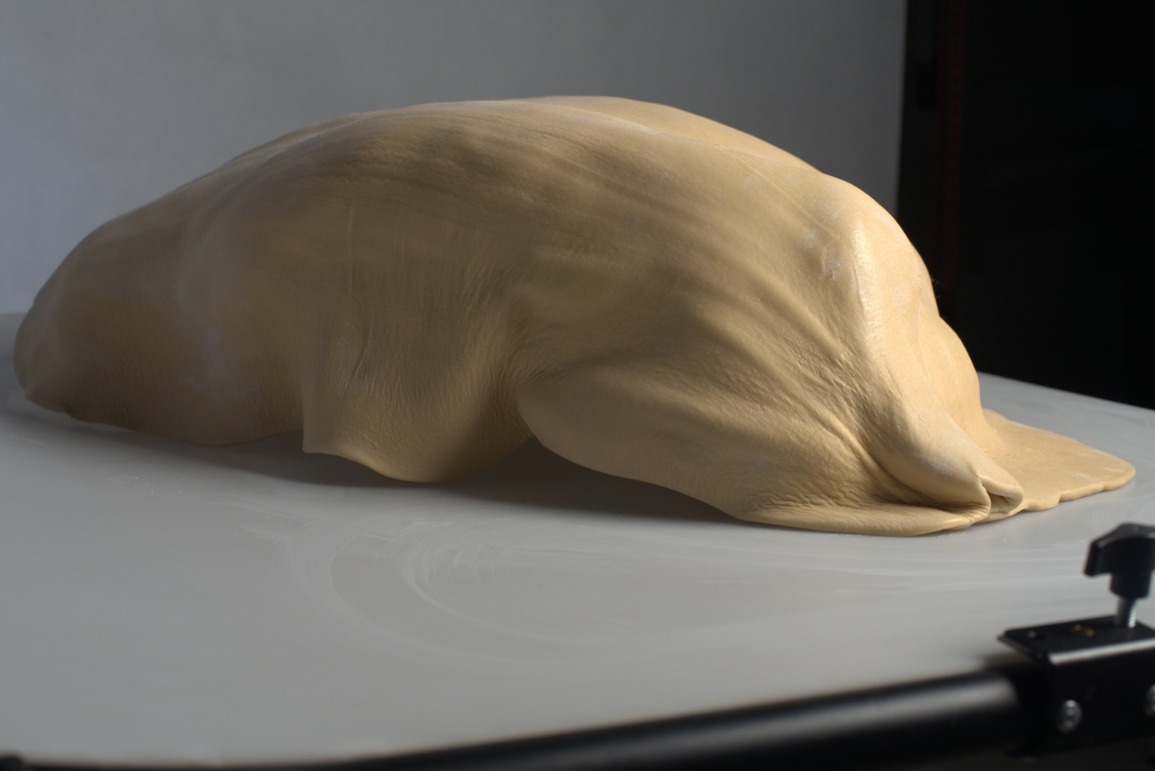
”The process of cognition” 2018, h 43 x 23 x 66 cm
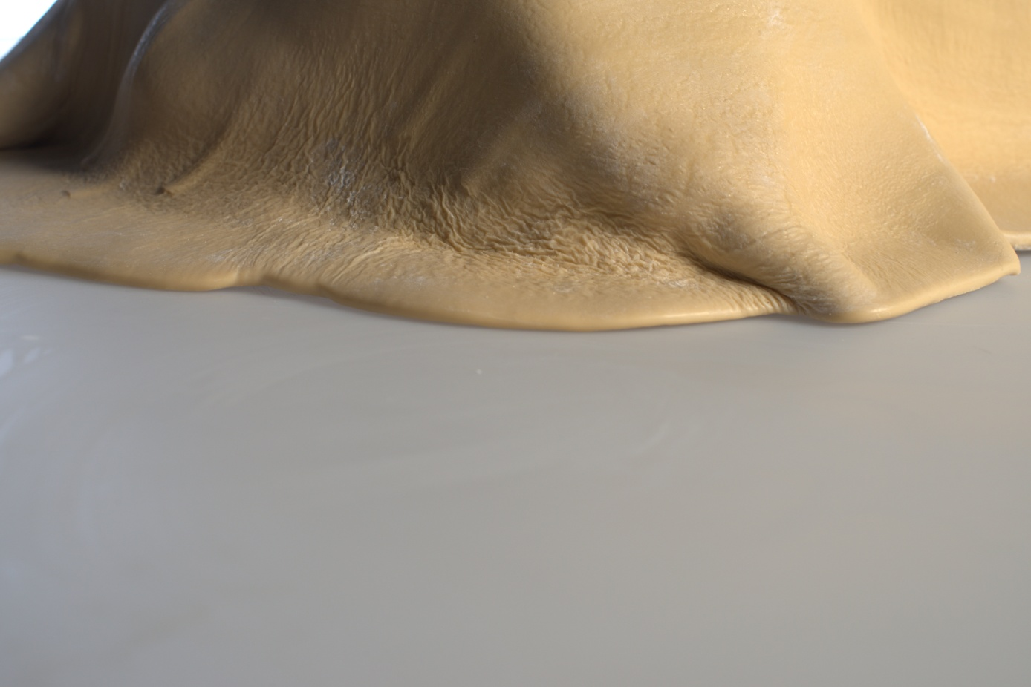

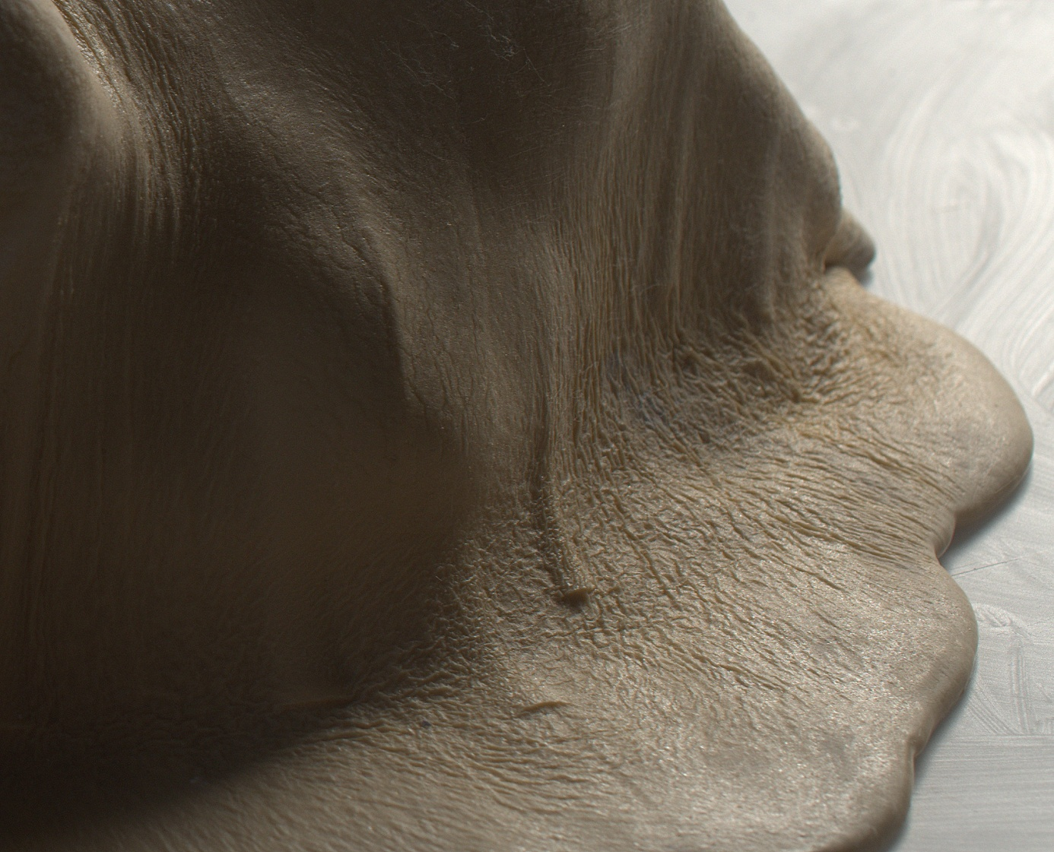

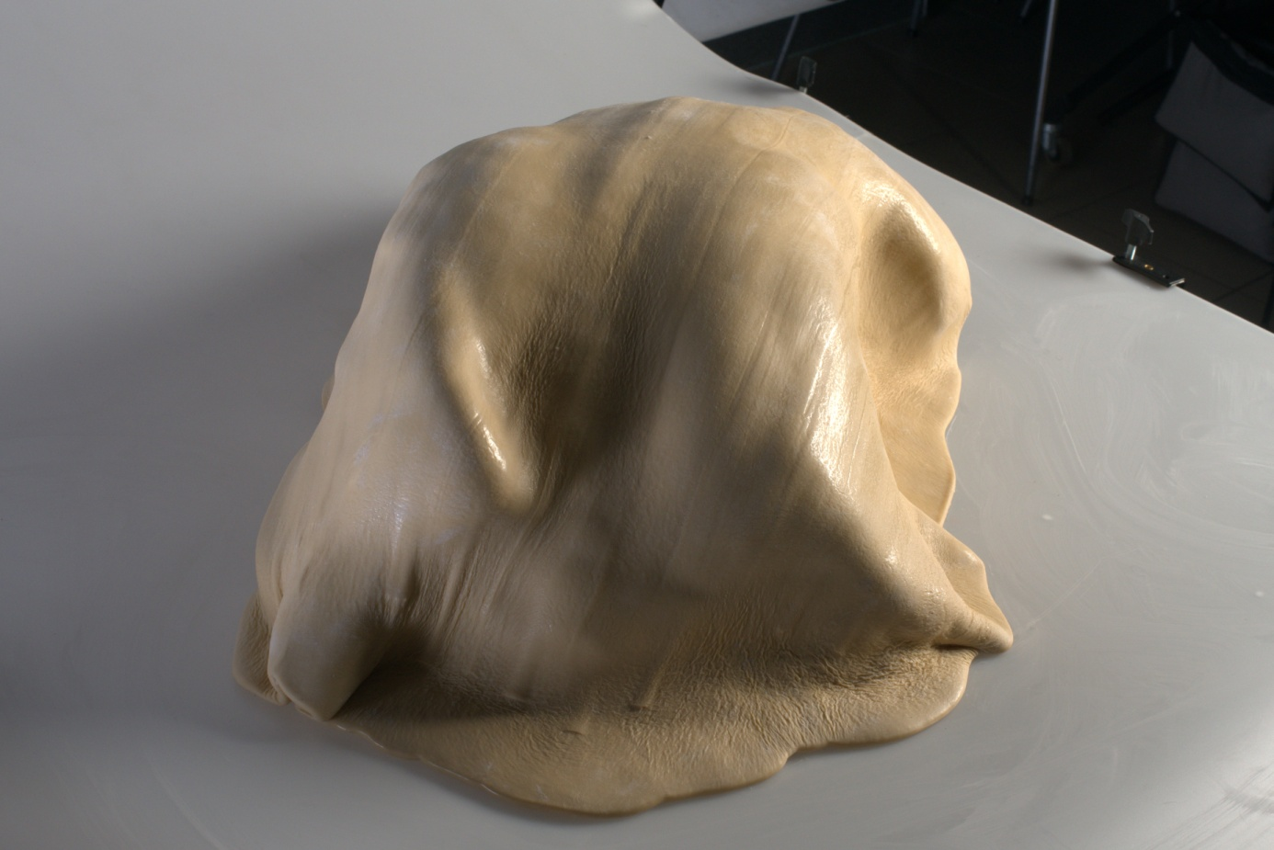

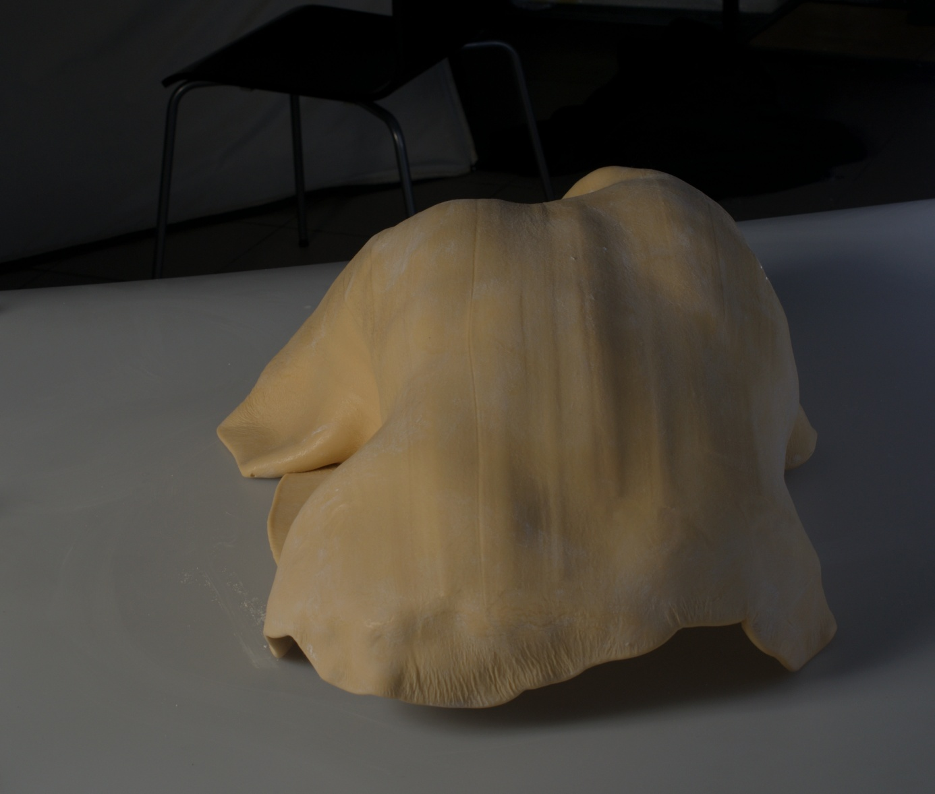

Embodied cognition
Alexander Lowen compared breathing to feeling: “To breathe deeply means to feel deeply” .
Achieving the indivisibility in the direction of action and transparency in the source of knowledge is the essence of the invaluable route during the process of cognition - self-awareness.
Direction should be consistent with our awareness, which, through the internal insight and the openness in the process of cognition lets go further on the road of development.
Being aware and understanding the awareness leads to the understanding of one’s own shape, which was described by this this American psychiatrist and the psychotherapist in his book The Betrayal of the Body.
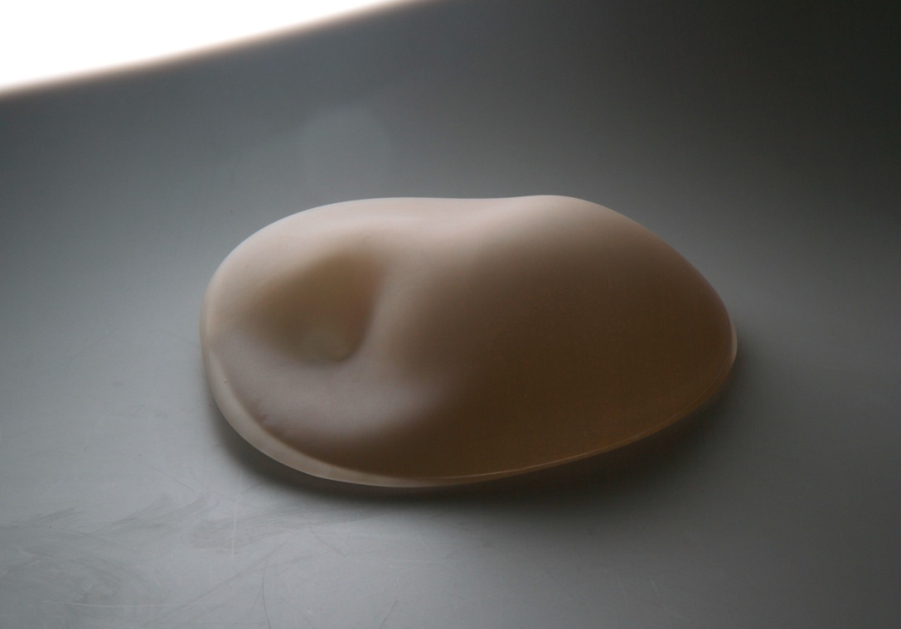
”The process of cognition” 2019, h 9 x 31x 36 cm

Organic thinking
As early as in the 17th century Descartes, the pioneer of the culture of reason, wrote in his letter to princess Elisabeth about the importance of cooperation between intellect, imagination and senses.
Merleau-Ponty uses the definition of “organic thinking” . The philosopher wrote about the “thinking that is free from connecting the data with the category of meaning that is external to them”.

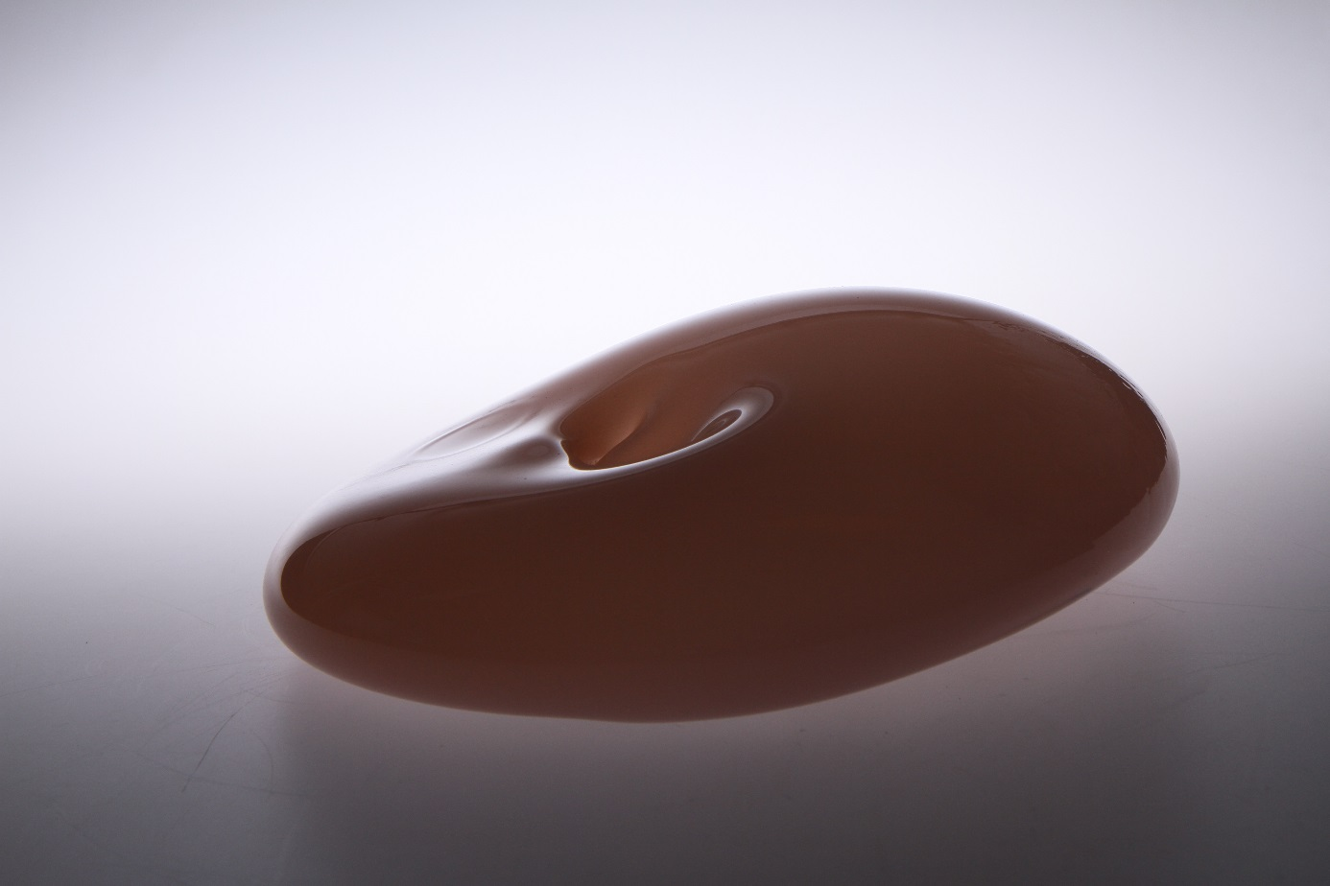

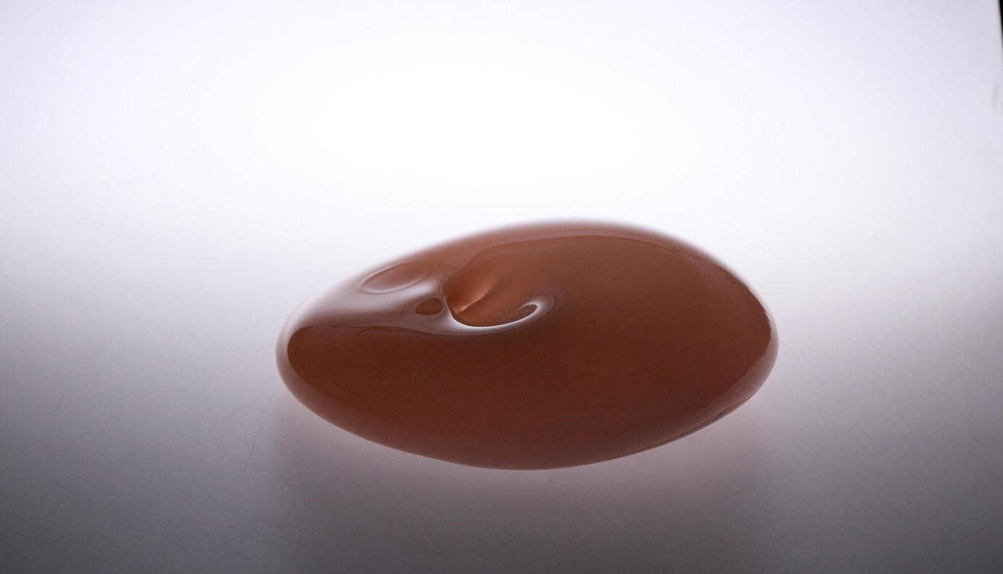

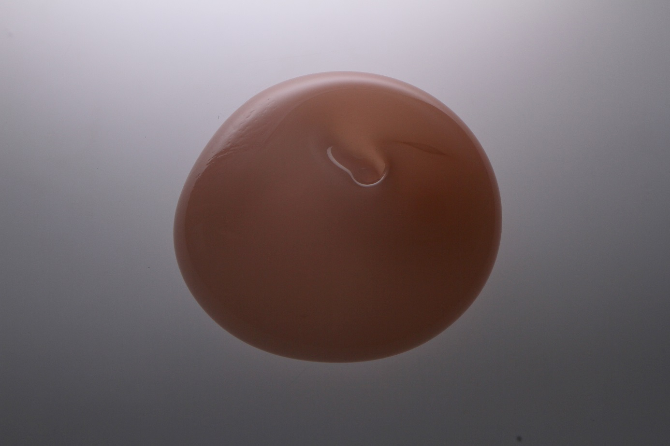
”The process of cognition” 2019, h 12 x 35 x 35 cm

The experience of body
The not-feeling, stiffened, closed and established body becomes subordinate to an idea. It is understood by the mind, and since we got to know the reason of the things, we have to think and to live in the world, in which, in order to know the soul, and get to the absolute spirit through it, we must be aware of everything that results in the discovery of one’s own body.
Lowen described the influence of the psychological sphere on the physical one in his writings. Let me quote the fragment which shows the significant effect of extrinsic factors on the internal system: “During my psychoanalytical practice, a patient who blocked the expression of thoughts and feelings, also ceased to breathe”.
I did not want to limit my research to psychology, although I am convinced that it is one of fundamental sciences and the best one in terms of exploring the process of becoming an individual.
In Phenomenology of Perception Merleau-Ponty writes that: “sensory experience is a vital process, just like reproduction, breathing or growing”.
It is not possible to restrict awareness that is connected with experiencing and feeling. The purely intellectual understanding is torn away from the whole of the organism from which it is derived and has an a priori established essence whose base is it itself. As it is unaware, it does not exclude authenticity, our organism shows the relation between the visual reception and corporal feeling.
The man has a defensive system of his organism that protects him from the excessive load. Every strong feeling and experience is recorded in our body. When the organism is overloaded, muscle strains occur, and they often deform the composition. The organism concentrates the energy on the pain. Human body is like a map. The pain is not only physical, but mental too.
Both visual and tactile experiences affecting the internal inspection in the process of cognition. As a sculptress I create through touch. However, I would not like to focus only on the impression in the cognition, but also on the essence of the influence of this feeling on cognition.

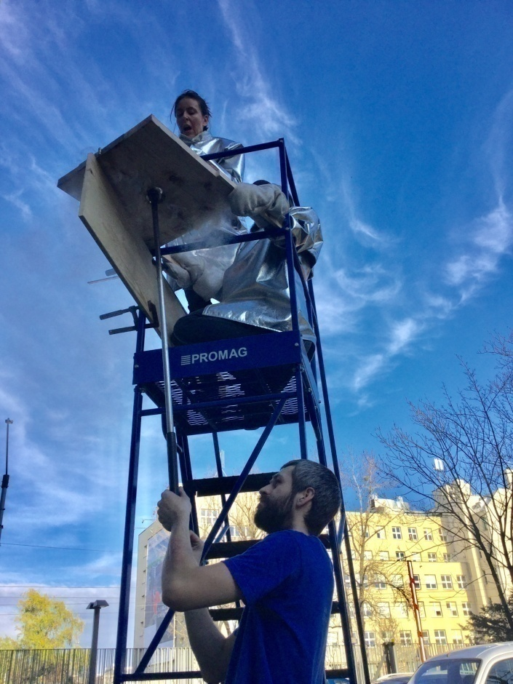
Glasswork of Wrocław Academy of Fine Arts, creative process, 2018
While creating I touch the glass and shape it in accordance with my feelings. Sartre thought that during the reception the whole body participates in the process of cognition. Ponty stated that: “The awareness means being with the thing by means of body. We learnt the movement when our body understood it, namely, when it incorporated it into its »world«. To move one's body means to aim at things, to let it answer their call that it receives without any presentation” .

Memory vs body
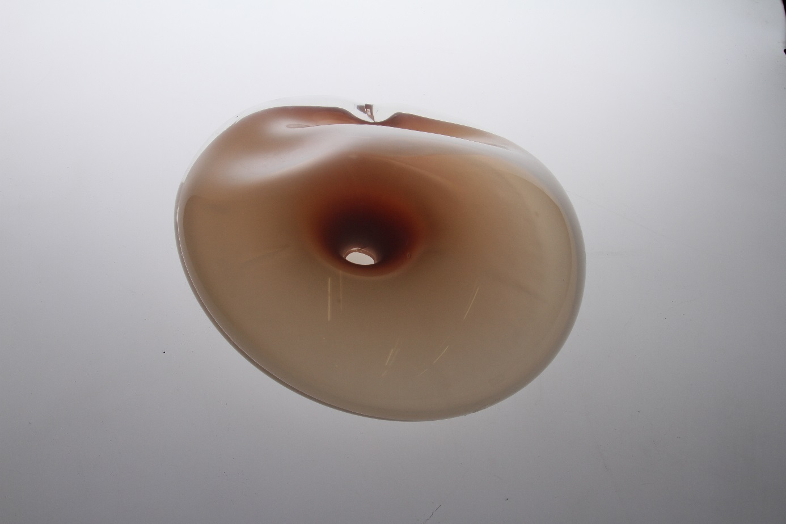

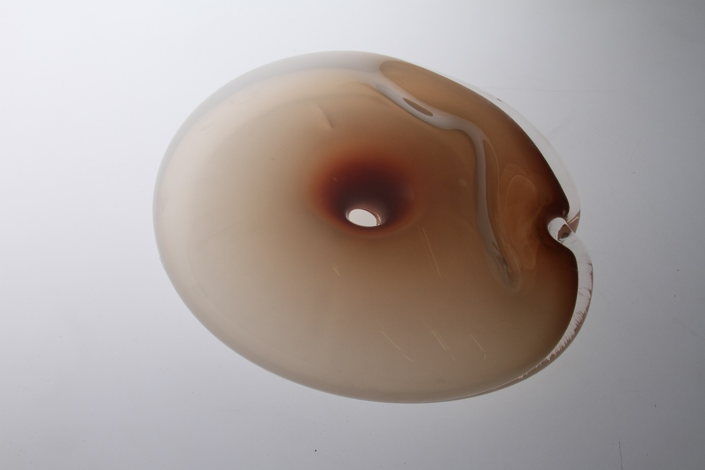

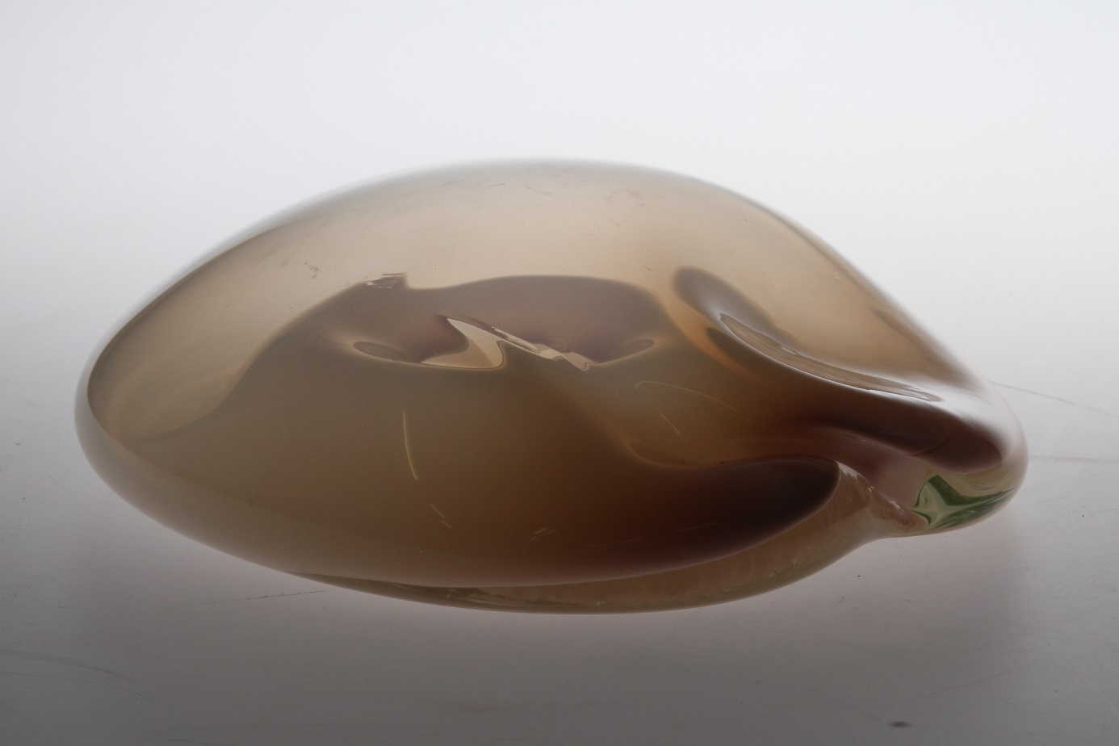

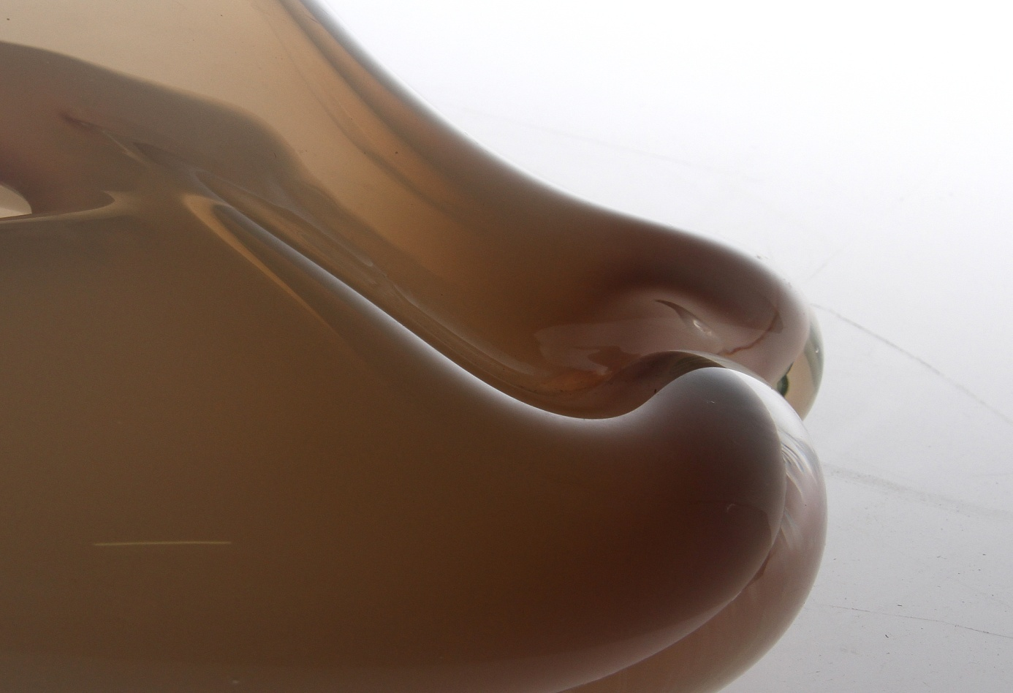

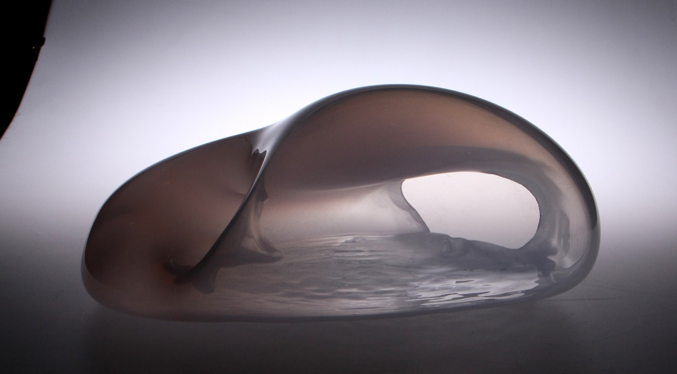

These all refers also to the body, which, through loss of the energy, muscle strains, shows the lack of contact with the defensive process of the organism; those are drives, self-preserving actions of an organism.
I see and feel, both through mind and body, what I would not notice If I was not aware or too much aware.
It takes place through the lack of energy and power to accomplish the work, the remains are worn out while acting constantly in thoughts.

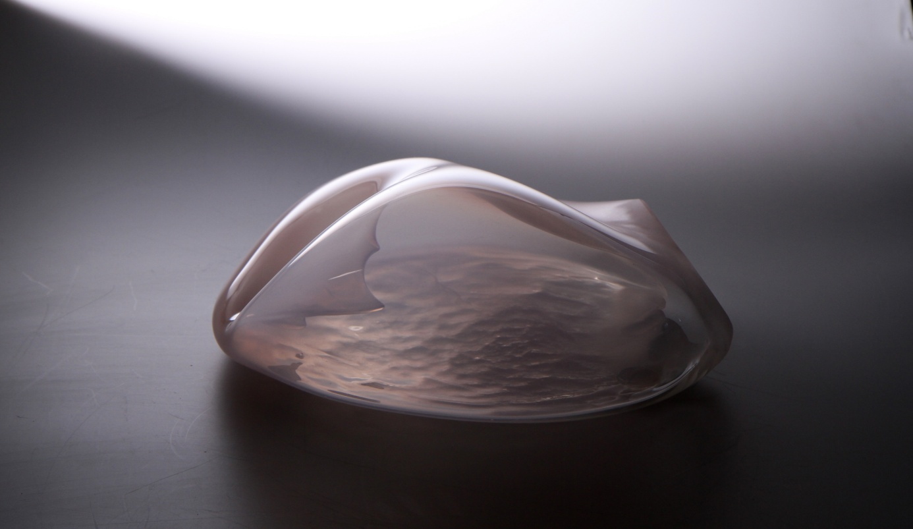

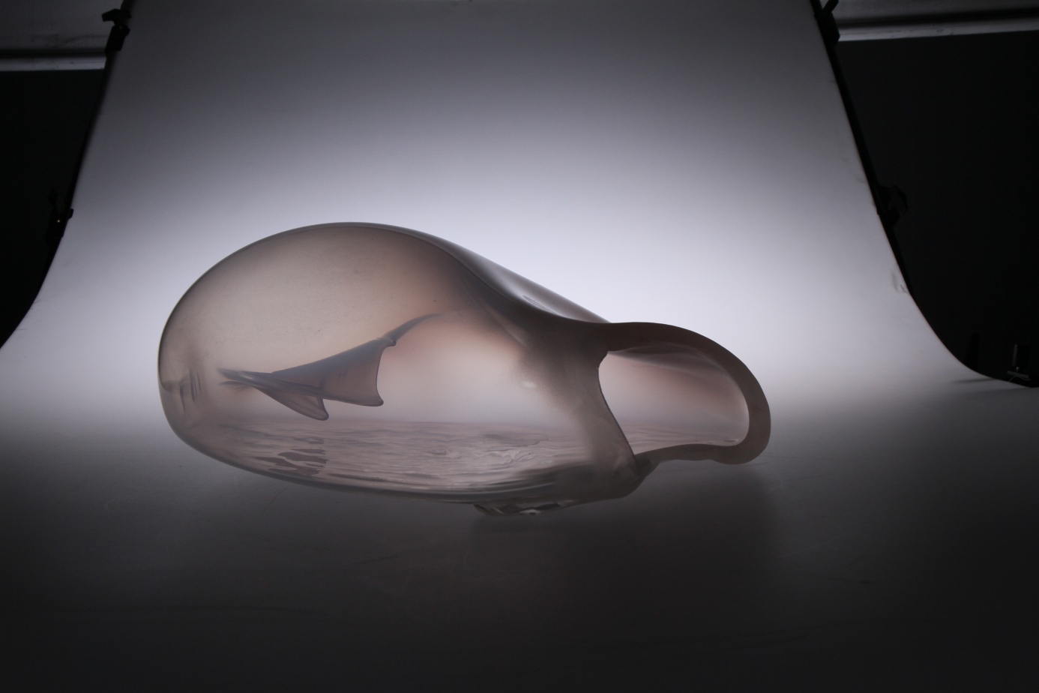

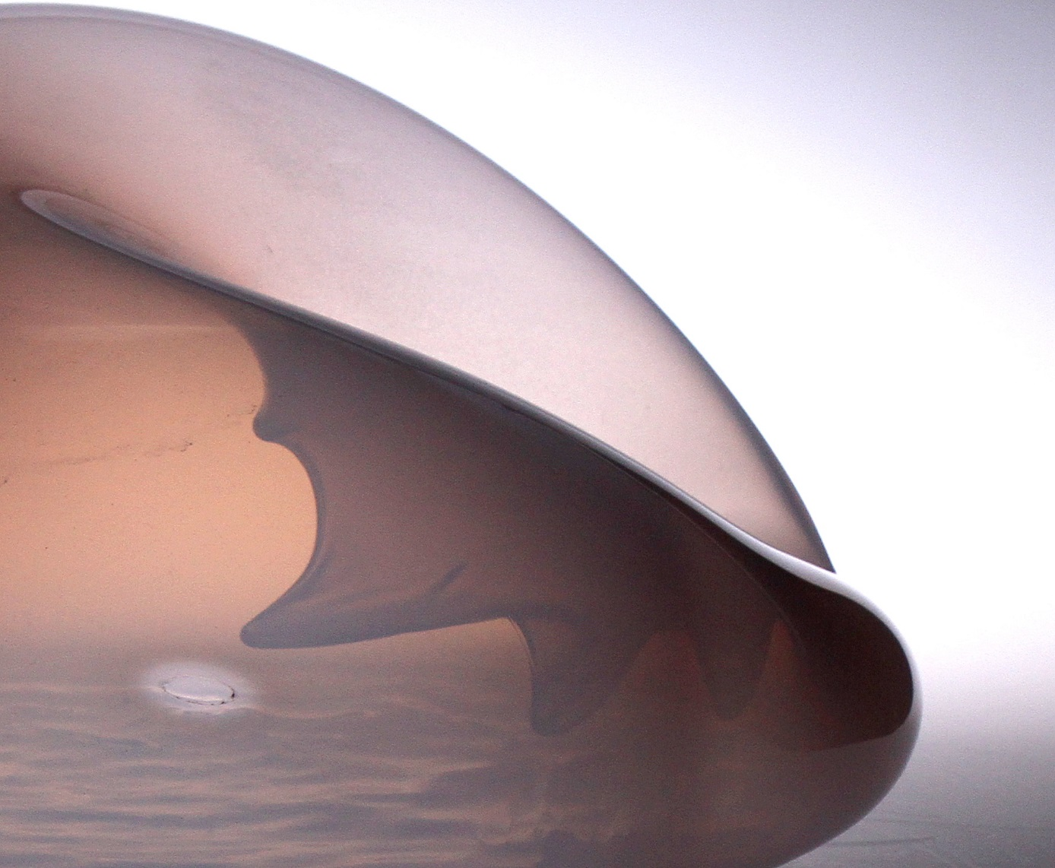

In Imaginary Sartre wrote about the counteracting of retention and pretention, and the other way round – also slow cleaning the knowledge can take place. It happens in the zone of half-shade, where smuggled images, empty states, fragments are to be found.
The habit consists of changing and copying the already taught movements. For example, we learn a dance and then reproduce it through mobility. Our body has an already constituted structure, thanks to which it reconstructs a mechanism.

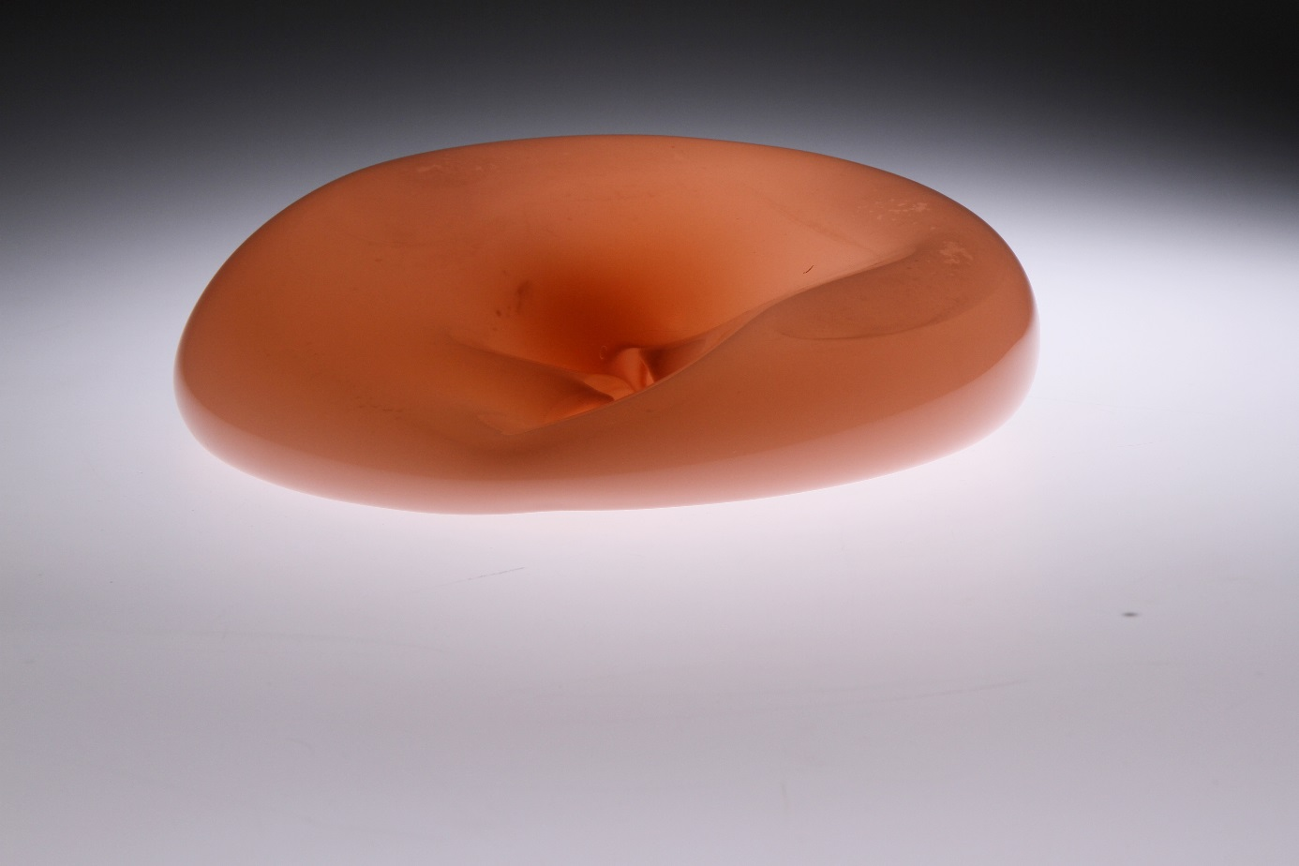
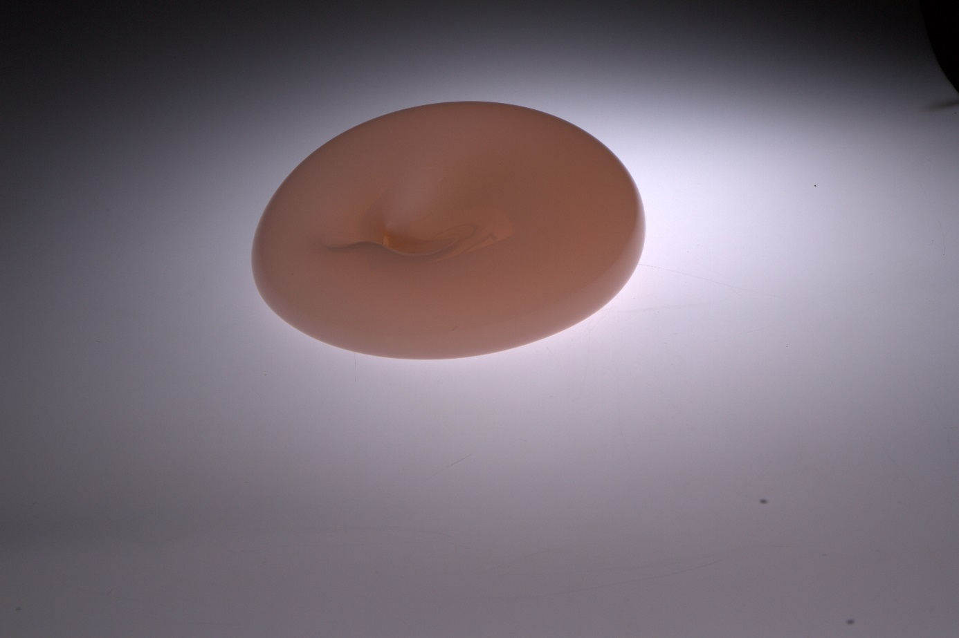

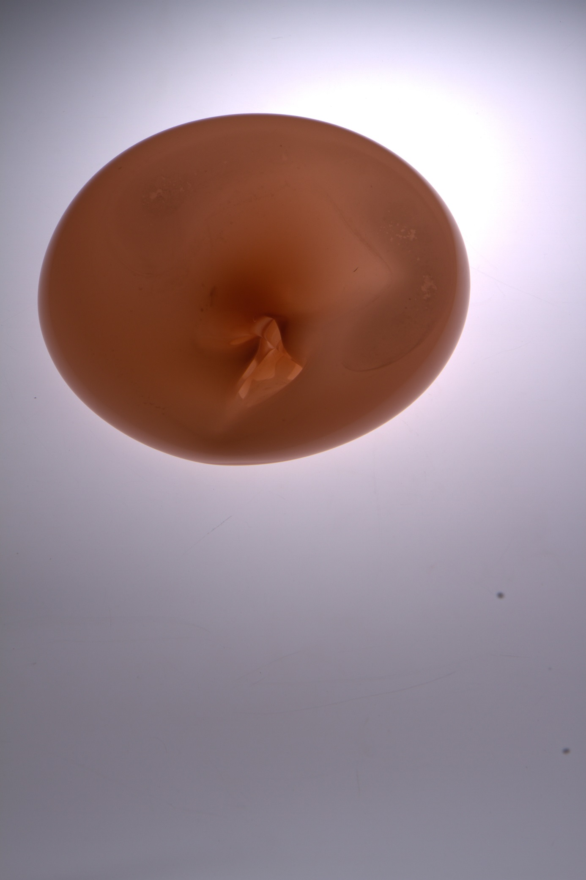

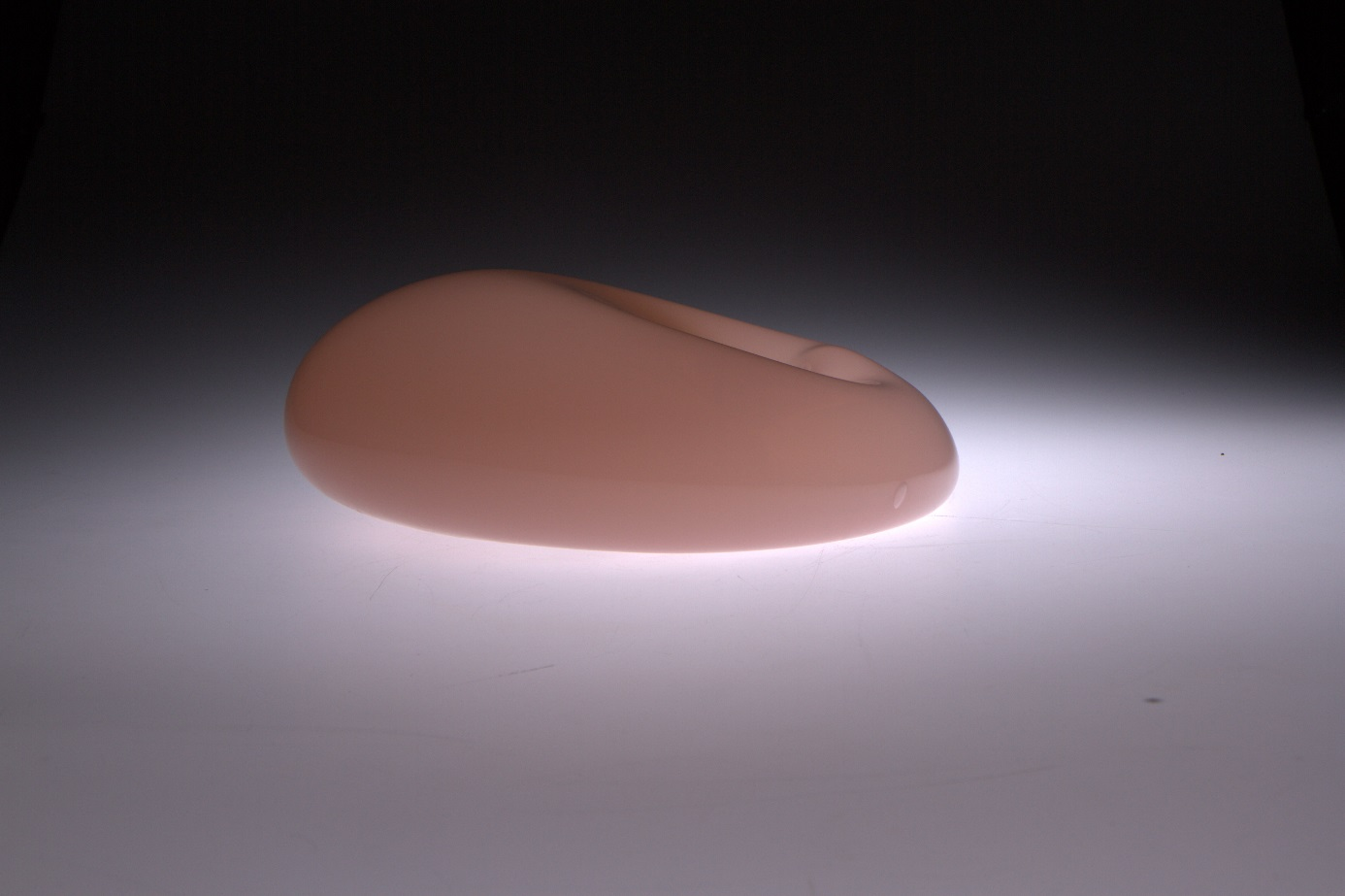

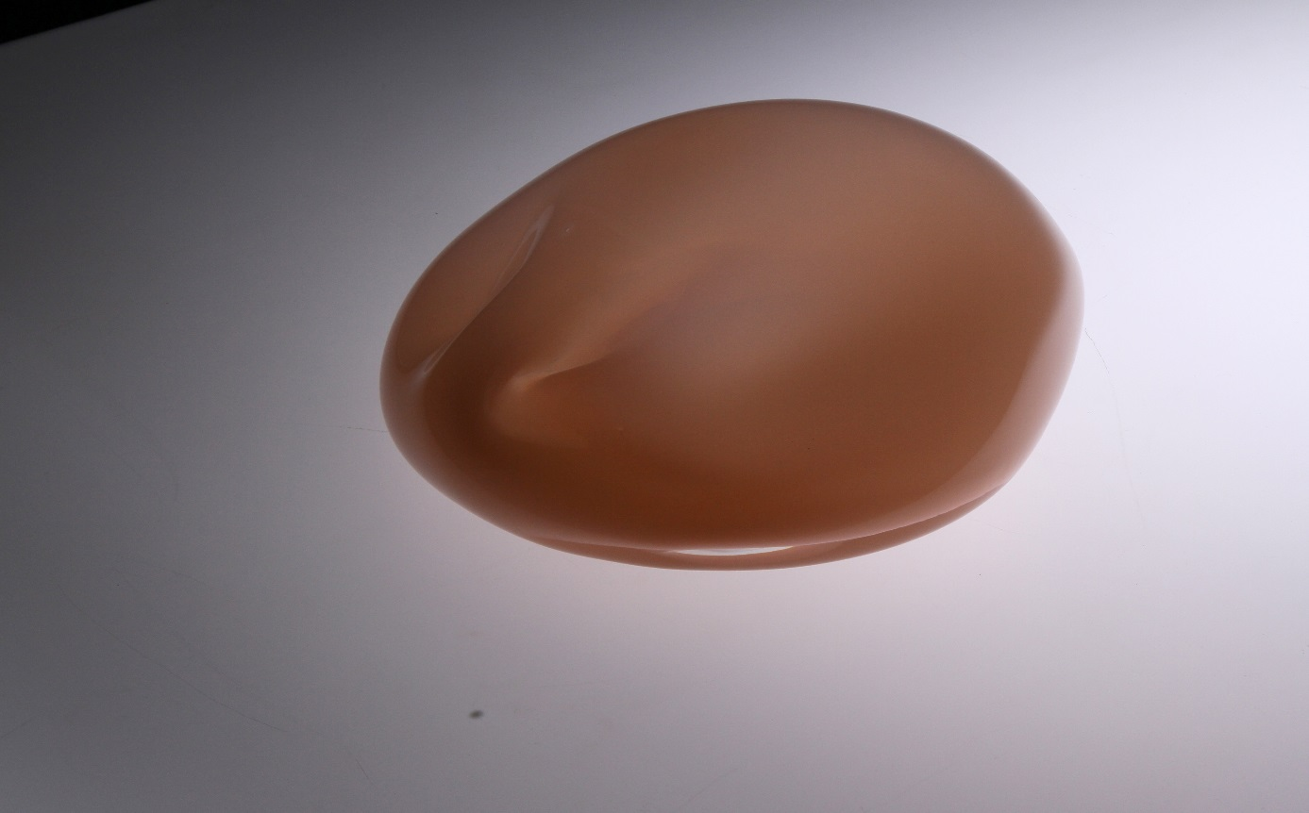

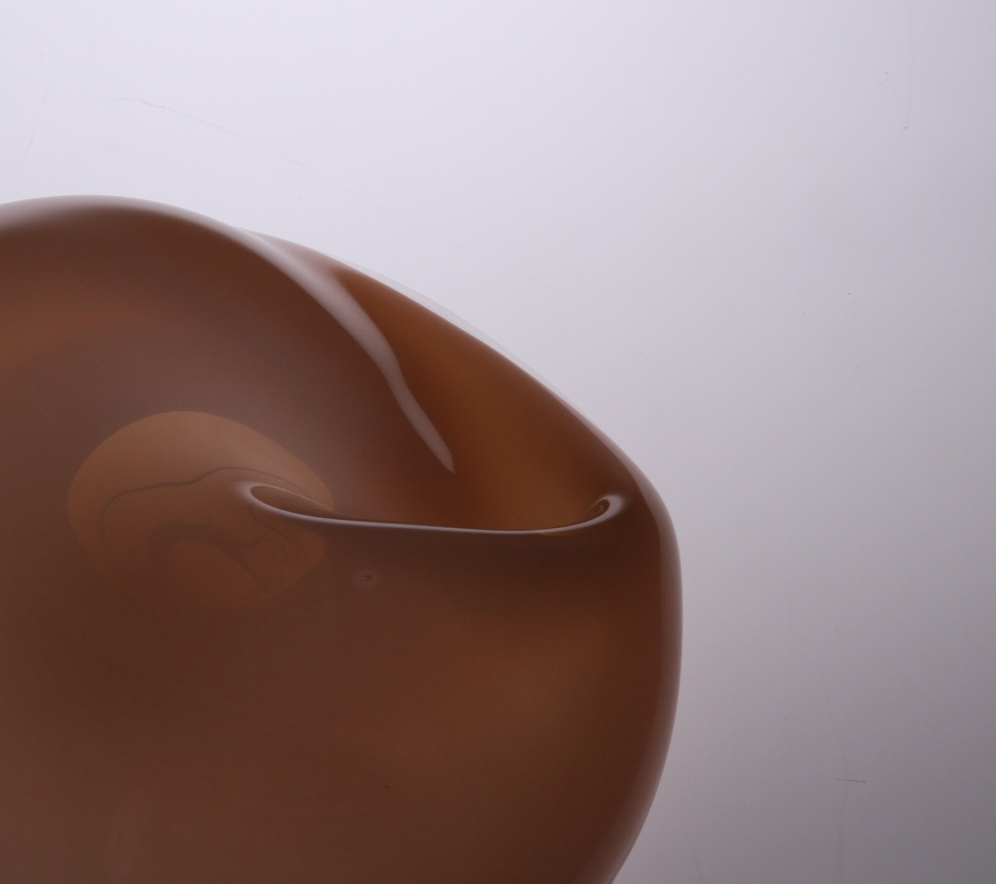

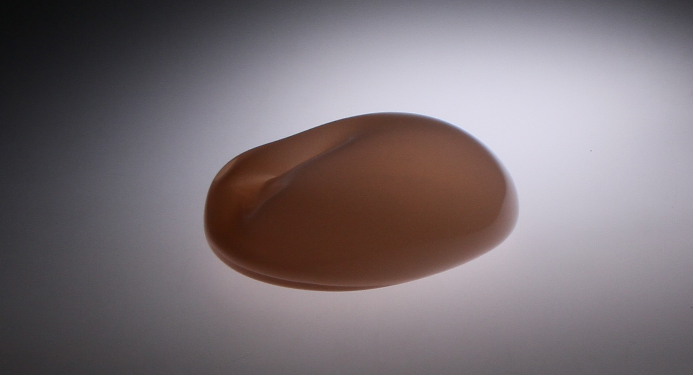

Conclusions
In my opinion, recognition does not exclude the act of cognition. It defines the process, situating it in a conceptual scheme to which we refer, while improving knowledge. It does not mean that it is closed, it is only defined
The acquired knowledge which is not established forever but takes part in a constant process of development influences the definition and sensitivity, internal insight and openness make it possible.
The creative process is spontaneous, even though it requires a lot of exploration, knowledge. It is not based on a theory only, since the artistic work would be based on control only, which is in contradiction with cognition. The vision in the process of depicting is supported with previous recognition. In order to exist, the image has to be known before.
The mind is not the only cognitive source. The embodied mind harmonizes with the environment, adapts itself to its structure – it is a natural process in a cognitive act
The cooperation of the mind with senses is indisputable.
Experiences belong to nature, and the psychological processes accompanying them constitute a crucial component of the awareness.
Experiences create identification – cognition. As an artist I have a privacy of impressions influenced by previous experiences. The concept of qualia referring to some quality, some mental state seems appropriate here.
My qualia are my own, current, direct experiences. They appear in the “current” memory, are these are qualities that are available only to me. It is the privacy of impressions, the state of feelings which are subjective, and therefore authentic.
Let me sum up with the statement that it is not possible to feel with body and mind in a the same way.

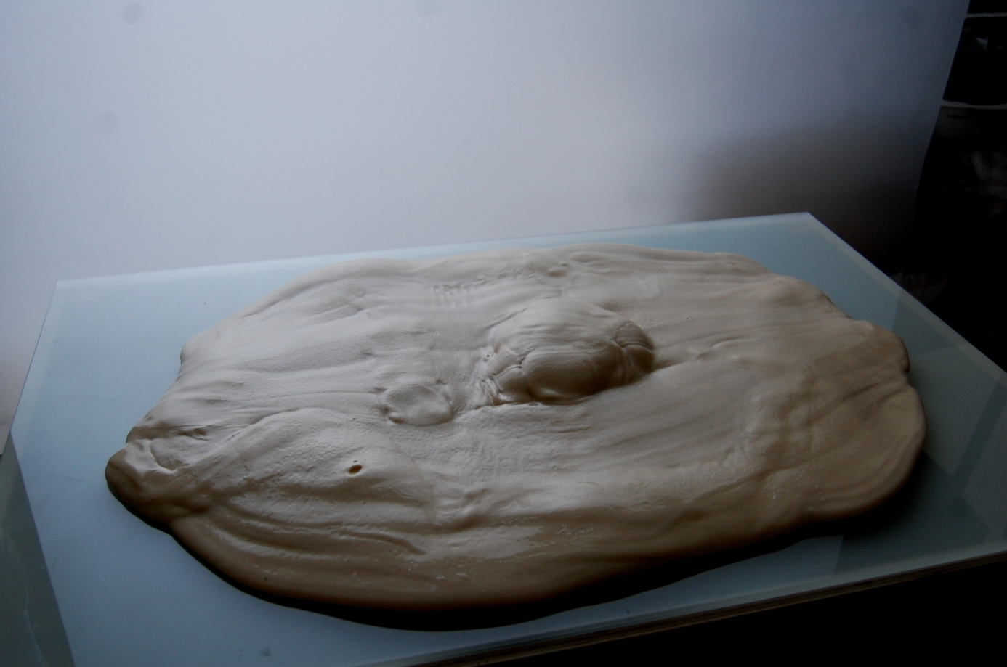

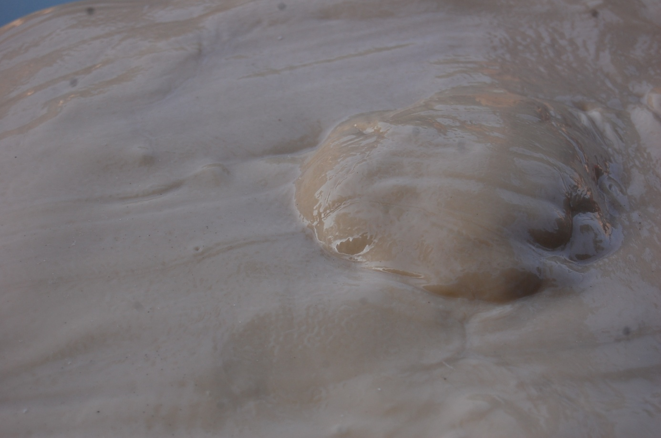

References
- Krueger D. W., Developmental and Psychodynamic Perspectives on Body, New York 1990.
- Lowen A., Duchowość ciała, trans. S. Sikora, Warszawa 2011.
- Lowen A., Zdrada ciała, trans. A. Pokojska, Koszalin 2012.
- Merleau-Ponty M., Fenomenologia percepcji, trans. J. Migański, M. Kowalska, Warszawa 2017.
- Sartre J.-P., Wyobrażenie. Fenomenologiczna psychologia wyobraźni, trans. P. Beylin, Warszawa 2012.

J.-P. Sartre, Wyobrażenie. Fenomenologiczna psychologia wyobraźni, trans. P. Beylin, Warszawa 2012, p. 133.
Ibidem, p. 156.
Ibidem, p. 167.
Ibidem, p.172.
Ibidem, p. 178.
Ibidem, p. 204.
Ibidem, p. 206.
M. Merleau-Ponty, Fenomenologia percepcji, trans. J. Migański, M. Kowalska, Warszawa 2017.
J.-P. Sartre, op. cit., p. 206.
Ibidem, p.207.
Ibidem, p. 221.
M. Merleau-Ponty, op. cit., s. 167.
J.-P. Sartre, op. cit., p. 132.
Ibidem, p. 267.
Ibidem, p. 269.
D. W. Krueger, Developmental and psychodynamic perspectives on body, New York 1990.
M. Merleau-Ponty, op. cit., p. 143.
J.-P. Sartre, op. cit., p. 204.
A. Lowen, Duchowość ciała, trans. S. Sikora, Warszawa 2011.
Idem, Zdrada ciała, trans. A. Pokojska, Koszalin 2012.
M. Merleau-Ponty, op. cit., s. 95.
Ibidem, s. 148.
M. Merleau-Ponty, op. cit., p. 28.
Ibidem, p. 158.
J.-P. Sartre, op. cit.

